Priest-in-Charge: The Revd Hannah Lins
07736 012011 revhannahlins@gmail.com
Assistant Priest: The Revd Peter Allan
www.severnloopparishes.org.uk 01939 290048 pallan412@gmail.com
Loop Safeguarding Officer: Mrs Philippa Herbert 01939 291352 Lay Pastoral Minister: Mrs Joyce Jagger
Sharing the Light in the Loop 01743 298285 weekly worship 07802 695954 pearhill1@outlook.com
Daily Hope – the national service 0800 804 8044
SEPTEMBER LOOP 2023
Weekly Collects, Readings and Reflection are on the website (see above.)

Worshipping Together

You will remember that in last month’s Loop I shared the lovely news that we now have a band of bell-ringers for two Sundays per month at Bicton- we are tremendously grateful, and it’s a delight to hear! It enriches our worship and (we hope!) blesses the community to know that there are people in church praying on their behalf.

This is just one example- as we begin a new academic year, we will be looking at the breadth of the worshipping life of our churches in the next round of PCCs. We have had some encouraging experiences this last year- with the introduction of all-age liturgy at Shrawardine; the scratch choir in the summer; our graveside services and now regular services of Morning Prayer at Battlefield. As the autumn term begins, we will prayerfully consider how God continues to affirm and challenge us in our corporate worship, as well as the wider life of the parish.

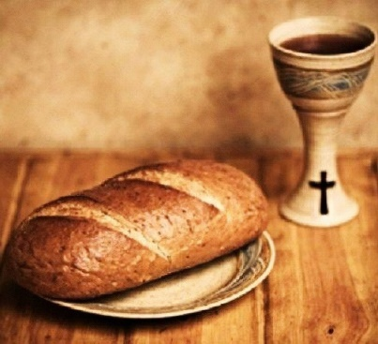
A lot of this has been enabled by the confidence we now have in the end of pandemic-related restrictions. With that in mind, can I also issue a gentle prompt about communion? The common cup returned to Severn Loop last year, and we have been operating a bit of a ‘mixed-mode’, with some continuing to intinct (including me until recently). It would be great if we could all move away from this, and towards receiving the common cup in the usual way once again. Whilst priest intinction is permitted; as members of the congregation we’re not supposed to intinct the wafer (dipping it in the wine)- a slightly awkward practice to have to confess to when it comes to visiting clergy! For those who don’t feel comfortable sipping the wine, we can of course receive in one kind only- so just the bread.

PCC meetings

Bicton- 7th September, 1.30pm, The Rectory
Albrighton- 12th September, 2pm, Albrighton House
Leaton- 12th September, 7.30pm, The Mission Church in Bomere Heath
Montford and Shrawardine- 13th September, 7.30pm, Montford Church
Fitz- TBC

Thank you to covering clergy

We are very grateful to The Ven. Kevin Roberts, who will be covering services at Montford and Shrawardine on 24th September, whilst Peter is on holiday.
Ride and Stride

On 9th September churches across the county will be taking part in Ride and Stride in aid of Shropshire Historic Churches Trust (with proceeds shared between them and the churches involved). Some folk from our congregations are being sponsored to cycle/ walk/ drive round as many as possible- do support them if you can! Churches around the Loop are also involved- it’s lovely to be able to welcome visitors to our buildings and grounds. If anyone in Bicton can help man the church for an hour on the day between 11am and 4pm, please let Wendy Horan or Clare Dixon know.

Forest Church
Our next Forest Church will be on the 10th September at Shrawardine. We are very excited to be on the land which would have been home to Dolly- the young girl who is memorialised in the Maiden’s Heart (which was discovered in church during lockdown). There will be some kit for engaging with nature (including microscopes), and seasonal crafts. We will also be unveiling ‘Dolly’s Gate’- which the current owner has installed in her memory. For most of us, we will park at the Castle Mound at the entrance to the village, but closer parking will be available for those of limited mobility.
Harvest

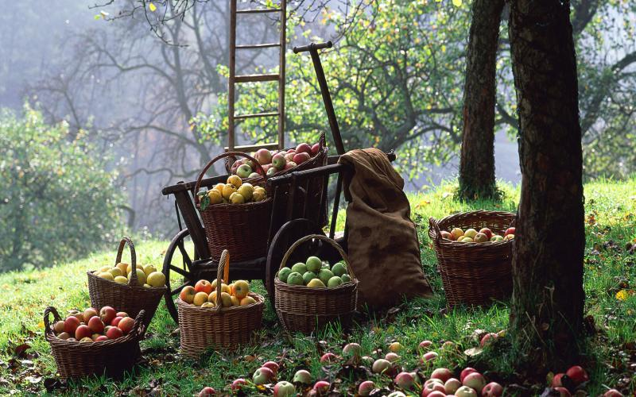
One of my favourite times of year! As we read about various (and increased) threats to global food supply, it is more important than ever to practice gratitude for what we do have, and to celebrate the earth’s abundant gifts- which we take for granted at our peril. There will be more details of services and lunches/ suppers in next month’s Loop, but here are a few dates for now (with details for the Harvest Lunch at Montford Parish Hall, as that gets sold out quickly!):

Festival Services | Meals
Bicton and Leaton- 1st October  Shrawardine- 8th October  Albrighton, Fitz and Montford- 15th October | Bomere Ecumenical Harvest Supper- 2nd October, 7pm for 7.30pm, The Mission Church. Bring and Share, with sign-up sheets at the back of church.  Fitz Harvest Supper- 7th October.  Harvest Lunch @Montford Parish Hall- 8th October, 12.30pm-12.45pm, Adults £10, Children under 11 £5, under-fives free. Tickets available from Tricia Jones (01743 850810), Cheri (01743 850200) or Esther (07484 777625). Bring your own drinks.

Men’s Breakfast

9th September at the Bridgewater Arms, Harmer Hill, beginning at 8.30am. The speaker will be our very own Fr. Peter Allan. To book a place, please contact David Fletcher (01939 290455, fletch.oldwoods@btopenworld.com) or Mike Bell (01939 291140, michaelbell90@hotmail.com).
Summer Coach Trip
Our summer coach trip will be on the 21st September and the destination is Worcester. There are details and sign-up sheets in all of our churches, and there are still a few places left- so please do book in if you would like to come. We will subsidise the cost of the trip if we can’t fill the coach, but we’d rather have passengers!

Diary Dates

Men’s Breakfast- 9th September, Bridgewater Arms, Harmer Hill, 8.30am.
Bomere Heath Village Fete- 9th September
Ride and Stride- 9th September, all day in churches around Shropshire.
Bicton CAMEO Coffee Morning- 14th September, 10.30am- noon. In church.
Bomere Parish Mag planning meeting- 18th September, 7.30pm, The Mission Church.
The Stepping Out Café in Bomere Heath- 27th September, 2.30pm-4pm.
Filling Station- Knockin Village Hall is on 19th September, 7.10pm for a 7.30pm start. The next one at Rodington Village Hall (SY4 4QS) is on 25th September, 7.15pm for a 7.30pm start.
REVS- 17th September, 9.30am-noon, Montford Bridge Café.
Fitz Community Coffee Morning- 23rd September, 10.30am- noon, Fitz Village Hall.
Pet Service- 23rd September, 11am, Bicton.

Home Groups

In addition to Seekers in Bicton (Monday evenings, led by Chris and Robin Oake), the Home Group in Bomere Heath is now back on at the home of Mike Bell (Cotsbrook, Old Woods). It meets on the 2nd and 4th Wednesdays of the month at 7.30pm. All welcome.

Confirmation

There is still time to come forward for Confirmation. The service will be on 5th November, 4pm @Leaton. Please do get in touch if you are interested.

Pet Service
For the first time since 2018, we are having a Pet Service at Bicton on 24th September, 11am. Please do come along with your pet as we give thanks for our non-human friends and recognise that they too are held in God’s love.

For Your Prayers
- For those dealing with the acute effects of climate breakdown- extreme heat, fires and flooding around the world. Particularly remembering the people of Hawaii, Greece and India.
- For those preparing for Baptism. We have two in September!
- For all who work in education as a new term begins.
- For harvest time for our local farmers.
- For places of war, refugees and all who seek safety.
Readings for September

Date | Psalm | First Reading | Second Reading/ Gospel
3rd September | 26.1-8 | Romans 12.9-21 | Matthew 16.21-28
10th September | 119.33-40 | Romans 13.8-14 | Matthew 18.15-20
17th September | 103.8-13 | Romans 14.1-12 | Matthew 18.21-35
24th September | 145.1-8 | Philippians 1.21-30 | Matthew 20.1-16
Harvest Thanksgiving | 65 | 2 Corinthians 9.6-15 | Luke 17.11-19
1st October | 25.1-8 | Philippians 2.1-13 | Matthew 21.23-32

SUNDAY SERVICES FOR SEPTEMBER 2023
 | Albrighton | Bicton | Bomere  Heath | Fitz | Leaton | Montford | Shrawardine
3rd September  Trinity 13  Green | 9.15 am  HC | 11 am  HC |  | 9.30am  HC BCP | 10.45 am  HC |  | 9.30 am  MP
10th September  Trinity 14  Green |  | 11 am  MP  1pm Baptism | 9 am  HC |  | 10.45 am  MP | 9.30 am  HC | 11 am  HC  3pm  Forest Church
17th September  Trinity 15  Green | 9.15 am  MP | 11 am  HC |  | 9.30am  HC BCP | 10.45 am  HC | 9.30 am  MP
24th September  Trinity 16  Green |  | 11 am  Pet Service | 9 am  HC |  | 10.45 am  MP  Baptism 1pm | 11 am  HC | 9.30 am  HC
1st October  Trinity 17  Green | 9.15 am  HC | 11 am  Harvest Communion |  | 9.30am  HC BCP | 10.45 am  Harvest Communion |  | 9.30 am  MP

HC- Holy Communion; MP- Morning Prayer; BCP- Book of Common Prayer

OTHER WAYS TO WORSHIP ON SUNDAYS
SUNDAY AT SIX 6 pm via Zoom – email Peter or Hannah to receive the link.
SHARING THE LIGHT IN THE LOOP- weekly phone line worship – see top of this page for the number.
DAILY HOPE – national phone line, see number above.
LICHFIELD CATHEDRAL- www.lichfield-cathedral.org 10.30 am Eucharist

