Priest-in-Charge: The Revd Hannah Lins
07736 012011 revhannahlins@gmail.com
Assistant Priest: The Revd Peter Allan
www.severnloopparishes.org.uk 01939 290048 pallan412@gmail.com
Loop Safeguarding Officer: Mrs Philippa Herbert 01939 291352 Lay Pastoral Minister: Mrs Joyce Jagger
Sharing the Light in the Loop 01743 298285 weekly worship 07802 695954 pearhill1@outlook.com
Daily Hope – the national service 0800 804 8044
OCTOBER LOOP 2023
Weekly Collects, Readings and Reflection are on the website (see above.)

Harvest Time

With 1st October being a Sunday, Harvest feels rather early this year! That’s a salutary reminder of the reality though- for our farming community the harvest has been underway for some time and we’re rather late to the season! Please do continue to pray for all those who work in agriculture, and for all of us in our stewardship of the earth. As usual our harvest donations will be going to local food distribution charities. It’s a difficult year for many. For example, the Foodbank is seeing record levels of use- and they are always so grateful for our contributions. There can be a bit of confusion about the difference between that and the Food Hub. Just to clarify, here is the distinction:
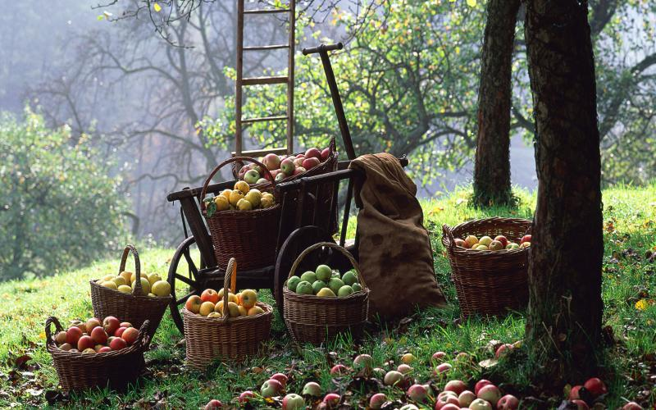
- Shrewsbury Foodbank (Barnabus)- provides food for only for those in need, who have gone through a referral process
- The Food Hub- is a distribution centre for leftover food from supermarkets. Anyone is welcome to this, because the principle is simply ‘no waste’- we’re all free to take food from the various food-shares around the town

In both cases, their very existence piques our conscience, and challenges to remember both the inequalities around us and the ways in which we could be less wasteful in our food consumption. These we bring to our worship, along with our thankfulness for the abundance we enjoy as the harvest is gathered in.

Festival Services | Meals
Bicton and Leaton- 1st October  Shrawardine- 8th October  Albrighton, Fitz and Montford- 15th October | Bomere Ecumenical Harvest Supper- 2nd October, 7pm for 7.30pm, The Mission Church. Bring and Share, with sign-up sheets at the back of church.  Harvest Lunch @Montford Parish Hall- 8th October, 12.30pm-12.45pm, Adults £10, Children under 11 £5, under-fives free. Tickets available from Tricia Jones (01743 850810), Cheri (01743 850200) or Esther (07484 777625). Bring your own drinks.

Coach Trip

Thank you to Gillian Steedman for organising a wonderful day out in Worcester- it was brilliantly planned-out and we all had a super time!

Christmas (shhh!)

It is far too soon to speak of this, but here are a few bits of information that are in addition to previous years…

After the joy of singing in Battlefield and Preston Gubbals last year, we’ve decided to hold carol services in both places this time round. As follows:

St Mary Magdalene, Battlefield- 2pm, Saturday, 16th December
St Martins, Preston Gubbals- 2pm, Sunday, 17th December

There is also going to be a Christmas Tree Festival at Leaton on 8th-10th December.

Finally, a bit like they do at the Hospice, we are going to have Light for a Loved One at Bicton- so throughout December there will be a tree lit in memory of loved ones, and a list of names on the notice board. There is information in Bicton Village News, or contact Hannah to find out more.

Ride and Stride

Well done to all involved in the Ride and Stride! Many of our churches were open for the first time, and people really appreciated the welcome. It was lovely to see a good number riding round- as I turned out of Bicton that morning, a tandem turned in!

Forest Church
Our next Forest Church will be stretching the definition! Probably better called Forest-Inspired Church, it’ll be held indoors (I know!) on 19th November at the Mission Church in Bomere Heath. It’ll be an afternoon of festive woodland crafting. More details to come…

Remembering with Love

Our annual Remembering with Love service will be at 3pm on 29th October, at Leaton. Please do email Hannah any names of loved-ones that you would like read out at this service. Please also keep local bereaved families in your prayers- we will be inviting a large number this year because sadly we’ve had far more funerals than we usually do.

Diary Dates

Bicton CAMEO Coffee Morning- 12th October, 10.30am- noon. In church.
The Stepping Out Café in Bomere Heath- 25th October, 2.30pm-4pm.
Filling Station- Knockin Village Hall is on 17th October, 7.10pm for a 7.30pm start. The next one at Rodington Village Hall (SY4 4QS) is on 23rd October, 7.15pm for a 7.30pm start.
REVS- 15th October, 9.30am-noon, Montford Bridge Café.

For Your Prayers
- For those living with the aftermath of the earthquake in Morocco and the flooding in Libya.
- For those preparing for Confirmation- our service is on 5th November, 4pm @Leaton.
- For our local homeless community, following the temporary closure of The Ark.
- For harvest time for our local farmers.
- For places of war, refugees and all who seek safety.

Readings for October

Date | Psalm | First Reading | Second Reading/ Gospel
Harvest Thanksgiving | 65 | 2 Corinthians 9.6-15 | Luke 17.11-19
1st October | 25.1-8 | Philippians 2.1-13 | Matthew 21.23-32
8th October | 80.9-17 | Philippians 3.4b-14 | Matthew 21.33-46
15th October | 23 | Philippians 4.1-9 | Matthew 22.1-14
22nd October | 96.1-13 | 1 Thessalonians 1.1-10 | Matthew 22.15-22
29th October | 1 | 1 Thessalonians 2.1-8 | Matthew 22.34-46
5th November | 34.1-10 | 1 John 3.1-3 | Matthew 5.1-12

SUNDAY SERVICES FOR OCTOBER 2023
 | Albrighton | Bicton | Bomere  Heath | Fitz | Leaton | Montford | Shrawardine
1st October  Trinity 17  Green | 9.15 am  HC | 11 am  Harvest Communion |  | 9.30am  HC BCP | 10.45 am  Harvest Communion |  | 9.30 am  MP
8th October  Trinity 18  Green |  | 11 am  MP | 9 am  HC |  | 10.45 am  MP | NO SERVICE | 11 am  Harvest Festival
15th October  Trinity 19  Green | 9.15 am  Harvest Festival | 11 am  HC |  | 9.30am  Harvest Festival | 10.45 am  HC | 9.30 am  Harvest Festival
22nd October  Trinity 20  Green |  | 11 am  MP | 9 am  HC |  | 10.45 am  MP | 11 am  HC | 9.30 am  HC
29th October  Last of Trinity  Green |  |  |  |  | 3pm Remembering with love |  | 10.30am  United Benefice Service
5th November  All Saints  White | 9.15 am  HC | 11 am  HC |  | 9.30 am  HC BCP | 10.45 am  HC |  | 9.30 am  MP

HC- Holy Communion; MP- Morning Prayer; BCP- Book of Common Prayer
OTHER WAYS TO WORSHIP ON SUNDAYS
SUNDAY AT SIX 6 pm via Zoom – email Peter or Hannah to receive the link.
SHARING THE LIGHT IN THE LOOP- weekly phone line worship – see top of this page for the number.
DAILY HOPE – national phone line, see number above.
LICHFIELD CATHEDRAL- www.lichfield-cathedral.org 10.30 am Eucharist

