

**Priest-in-Charge:** The Revd Hannah Lins

07736 012011 [revhannahlins@gmail.com](mailto:revhannahlins@gmail.com)

**Assistant Priest:** The Revd Peter Allan

[www.severnloopparishes.org.uk](http://www.severnloopparishes.org.uk) 01939 290048 [pallan412@gmail.com](mailto:pallan412@gmail.com)

**Loop Safeguarding Officer:** Mrs Philippa Herbert 01939 291352 **Lay Pastoral Minister:** Mrs Joyce Jagger

**Sharing the Light in the Loop** 01743 298285 weekly worship 07802 695954 [pearhill1@outlook.com](mailto:pearhill1@outlook.com)

Daily Hope – the national service 0800 804 8044

**MAY LOOP 2023**

**Weekly Collects, Readings and Reflection are on the website (see above.)**

**Dementia Friendly Churches**

*I came that they may have life, and have it abundantly.*

*John 10.10*

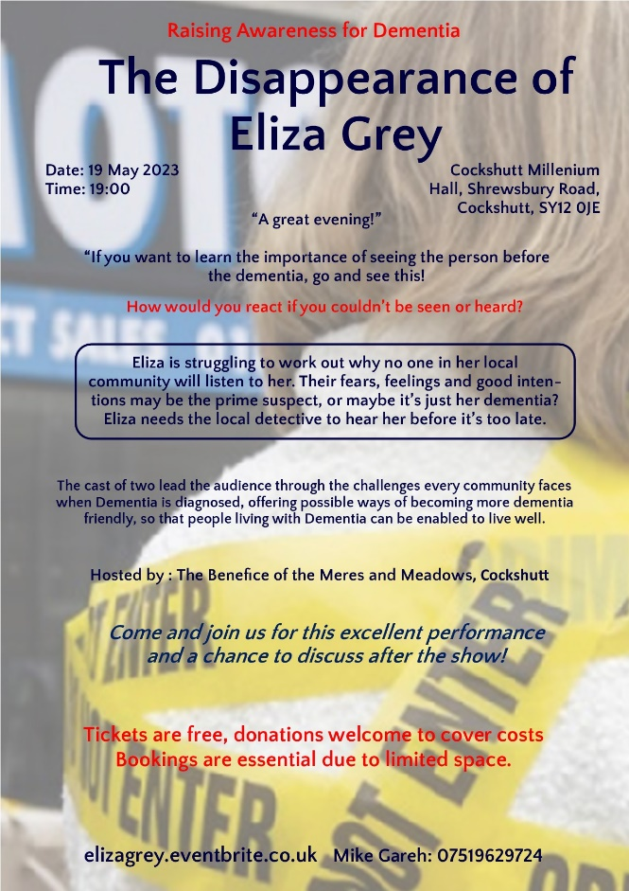

As you probably know, the churches around Severn Loop have been part of the *Dementia Friendly Churches* initiative for a number of years now. Many years ago we had some training to help us understand how to be a welcoming presence to those living with Dementia, and how to be part of a community who recognises the importance of enabling all to live a full and abundant life. We have been really heartened by the recent decision of both our church schools to become *Dementia Friendly* as well- and it was a joy to join one staff body for a training session last week. As people spoke about their own experiences and those of the children they teach, we very quickly became aware that we were on holy ground. Everyone had a story to tell. As part of the schools’ commitment, they are hoping to get more involved with the church community, and to build up friendships across generations. We look forward to the blessings that will bring!

It’s also been suggested that it might be a good time for us to refresh our training too- so we will look into how we might do that in the coming months. In the meantime if you want to explore more about the experience of living with Dementia, Cockshutt parish are putting on a production of *The Disappearance of Eliza Grey* on 19th May at 7pm (poster above)- tickets are free but booking is essential (elizagrey.eventbrite.co.uk).

**Diary Dates**

**Bicton CAMEO Coffee Morning-** 11th May, 10.30am- noon. In church.

**The Stepping Out Café in Bomere Heath-** 31st May, 2.30pm-4pm

**Filling Station**- Knockin Village Hall is on 16th May, 7.10pm for a 7.30pm start. The next one at Rodington Village Hall (SY4 4QS) is on 22nd May, 7.15pm for a 7.30pm start.

**British Legion Service**- 4th June, 6pm, Holy Trinity, Bicton.

**REVS**- 21st May, 9.30am-noon, Montford Bridge Café.

**Severn Loop Summer Celebration!**

We are very excited about our summer celebration on Corpus Christi- Thursday, 8th June. We hope it’ll be a joyful opportunity to have a bit of a party! Please feel warmly welcome to come along to the Sung Eucharist at Leaton at 4pm and/ or drinks in the garden at Albrighton House from 5pm (by kind invitation of Joyce and David Jagger). There is no need to book or RSVP.

If you would like to sing in the Eucharist, then please let Hannah or Peter know. As was the case with the Coroners Conference at Albrighton, we will be a home-grown, scratch choir- and we are looking for as many of you as possible to join in!

**Coronation Plans**

We are encouraging you all to get involved in any community events and celebrations. There will be our usual pattern of services on the Sunday morning (but please note that Montford will have a service of Morning Prayer that day, rather than Shrawardine), with the added blessing of an Ecumenical service at Leaton. Here are a few details of other plans, but it’s by no means an exhaustive list- the parish magazines have details of other opportunities across the whole weekend:

**Montford and Shrawardine Parish Picnic, 7th May, 12.30pm**On the Millennium Green (or at the Parish Hall if the weather is wet.) Bring a rug or chairs, and a picnic lunch, plus wine and beer if you want to. **Free desserts, tea, coffee and squash.** Family games on the Green.

**Fitz Parish Coronation Lunch, 7th May, Fitz Village Hall, 1pm for 1.30pm**

Tickets: Adult £6, Child (under 11yrs) £3: Ann Malpass - 01743 850527 or Julie Kaye - 01743 850722

*The bells will also be ringing at different points over the weekend at Bicton, Leaton and Montford.*

**Forest Church**

Our next Forest Church will be on the 4th June, 3pm at Leaton Forest (by kind invitation of Mr Charles Bridgeman). We are hoping for a lovely, balmy afternoon enjoying the countryside- with plenty of wildlife and things to do!

**British Legion Service**

We are delighted to be welcoming the Royal British Legion for their annual service at Holy Trinity, Bicton, 4th June 2023. There will be no service in the morning that day, instead we gather at 6pm for a parade from the village hall, followed by a service in church. Please do feel warmly welcome to come along- this year we have the **Porthywaen Brass Band** with us- who are brilliant!

**Save the Date**

Fitz Social Committee are organising a traditional community fete in the walled garden at Peverey from 2.30pm on **Saturday, 10th June**. More details to come soon…

**Men’s Breakfast**

Saturday 13th May, 8.15am-8.30am, Bridgewater Arms, Harmer Hill, £10

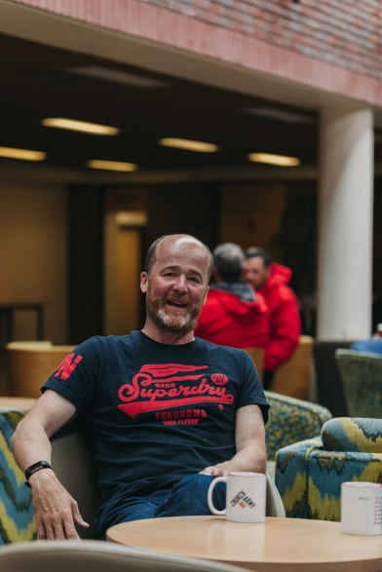

*Come and have a great breakfast in good company* *and when we have finished our meal, listen to a speaker:* Captain Neville Willerton, Church Army Director of operations. Neville oversees the frontline work for Church Army and develops new work and partnerships as well. Neville is a Commissioned Evangelist and has worked with them since 1999. He is inspired by the work that Church Army does, especially the projects that he leads in working with people who are profoundly unchurched and the work on the margins of society. Neville and Church Army are experiencing significant growth in their pioneering work. He lives with his family in Shropshire.

Do contact David Fletcher (01939 290455) or Mike Bell (01939 290140) if you would like to come along.

**For Your Prayers**

* For those preparing for Baptism or Marriage. We have lots over the summer months!
* For the Coronation- His Majesty the King as Supreme Governor of the Church of England, and for the Royal Family.
* For places of war.
* For refugees and all who seek safety.
* For our local farming community, and all who work in the public sector.
* For the work of our Foodbank, Food Hub, The Ark, Street Pastors and other local charities.

**Readings for May**

|  |  |  |  |
| --- | --- | --- | --- |
| **Date** | **Psalm** | **First Reading** | **Second Reading/ Gospel** |
| **Sun 7 May**  5th of Easter | 31.1-5,15-16 | Acts 7.55-60  At Leaton: Proverbs 8.1-16  At Montford: to be confirmed | John 14.1-14  At Leaton: Luke 22.24-30  At Montford: to be confirmed |
| **Sun 14 May**  6th of Easter | 66.7-18 | Acts 17.22-31 | John 14.15-21 |
| **Thurs 18 May**  Ascension Day | 93 | Acts 1.1-11 | Luke 24.44-53 |
| **Sun 21 May**  7th of Easter | 68.1-10,32-35 | Acts 1.6-14 | John 17.1-11 |
| **Sun 28 May**  Pentecost | 104.26-36,37b | Acts 2.1-21 | John 20.19-23 |
| **Sun 4 June**  Trinity Sunday | 8 | 2 Corinthians 13.11-13 | Matthew 28.16-20 |

**Morning Prayer on Wednesday mornings, 10am at Battlefield**

As summer draws near (we hope!), you might like to consider joining Judith Hall at St Mary Magdalene, Battlefield for a short service of Morning Prayer at 10am on Wednesdays (from the Celtic liturgy). All are welcome- you could even bring your dog and go for a walk afterwards, or have a coffee in the café!

**Deanery Synod**

Deanery Synod is made up of representatives from local Anglican churches (from the Shrewsbury and Wrockwardine areas), and it meets three times a year. Following our recent round of APCMs, we have elected three reps from Severn Loop- Janet Leake, Mike Bell and Stuart Leighton. Meetings are open to all, and if you would ever like to attend, then do feel most welcome. The next one is on Wednesday, 12th July, 7 for 7.30pm at Holy Trinity, Uffington. Each meeting has a different theme- to find out more, do speak with one of our reps- we have capacity within Severn Loop to elect a few more people on if anyone is interested!

**SUNDAY SERVICES FOR APRIL 2023**

***HC- Holy Communion; MP- Morning Prayer; BCP- Book of Common Prayer***

|  |  |  |  |  |  |  |  |
| --- | --- | --- | --- | --- | --- | --- | --- |
|  | **Albrighton** | **Bicton** | **Bomere**  **Heath** | **Fitz** | **Leaton** | **Montford** | **Shrawardine** |
| **7th May**  **Coronation!** | 9.15 am  HC | 11 am  HC |  | 9.30 am  HC BCP | 10.45am  HC  (joint with Methodist friends) | 9.30am  MP |  |
| **14th May** |  | 11 am  MP | 9 am  HC  Archdeacon Paul Thomas |  | 10.45 am  MP | 9.30 am  HC | 11 am  HC |
| **18th May**  **Ascension Day** |  |  | 7pm  HC |  |  |  |  |
| **21st May** | 9.15 am  MP | 11 am  HC |  | 9.30 am  HC BCP | 10.45 am  HC |  | 9.30am  MP |
| **28th May**  **Pentecost** |  | 11 am  MP | 9 am  HC |  | 10.45 am  MP | 11 am  HC | 9.30 am  HC |
| **4th June**  **Trinity Sunday** | 9.15 am  HC | 11 am  HC  6pm  British Legion Service |  | 9.30 am  HC BCP | 10.45am  HC  3pm Forest Church |  | 9.30am  MP |

**OTHER WAYS TO WORSHIP ON SUNDAYS**

SUNDAY AT SIX 6 pm via Zoom – email Peter or Hannah to receive the link.

SHARING THE LIGHT IN THE LOOP- weekly phone line worship – see top of this page for the number.

DAILY HOPE – national phone line, see number above.

LICHFIELD CATHEDRAL- www.lichfield-cathedral.org 10.30 am Eucharist

