Priest-in-Charge: The Revd Hannah Lins
07736 012011 revhannahlins@gmail.com
Assistant Priest: The Revd Peter Allan
www.severnloopparishes.org.uk 01939 290048 pallan412@gmail.com
Loop Safeguarding Officer: Mrs Philippa Herbert 01939 291352 Lay Pastoral Minister: Mrs Joyce Jagger
Sharing the Light in the Loop 01743 298285 weekly worship 07802 695954 pearhill1@outlook.com
Daily Hope – the national service 0800 804 8044
FEBRUARY LOOP 2024
Weekly Collects, Readings and Reflection are on the website (see above.)

Entering Lent Together

As the seasons roll by, the good old Church of England provides us with a wealth of liturgy to mark the various moments in our worshipping life together. Some do the job better than others, and we all have our favourites! The preface for Lent is (in my humble opinion!) particularly beautiful and profoundly challenging:
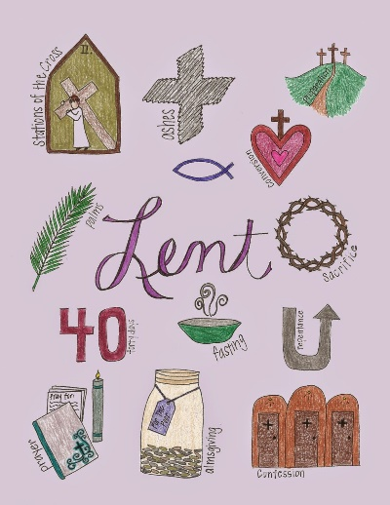
For in these forty days
you lead us into the desert of repentance
that through a pilgrimage of prayer and discipline
we may grow in grace
and learn to be your people once again.
Through fasting, prayer and acts of service
you bring us back to your generous heart.
Through study of your holy word
you open our eyes to your presence in the world
and free our hands to welcome others
into the radiant splendour of your love.

As we gather round the Lord’s table week by week and hear those words, may our prayer be that through our Lent disciplines we will (re)discover the heart of God and be transformed.

As is our custom, Lent will begin with two services on Ash Wednesday (14th February)- as below:

- 11.30am Eucharist at Bicton (with ashing), followed by a soup lunch. If possible, please let Wendy Horan know if you are staying for the lunch (01743 850237).
- 6.30pm, The Methodist Chapel, Bomere Heath- an Ecumenical service to mark our journey into Lent.

We will then have a series of midweek Eucharists running from 21st February to the 20th March inclusive (Wednesdays, 10am, The Mission Church in Bomere Heath), followed by coffee and a discussion based, as last year, on the Visual Commentary on Scripture.

Forest Church
Our next Forest Church will be on 25th February, 3pm at Huffley Farm, Albrighton. Please note the change of venue- the lambs will be there, so we will certainly be able to see them! Please wrap up warm and come prepared to see various animals and get involved in some sheep-ish crafts.

Diary Dates

Bicton CAMEO Coffee Morning- 8th February, 10.30am- noon. In church.
The Stepping Out Café in Bomere Heath- 28th February, 2.30pm-4pm, Mission Church
Filling Station- Knockin Village Hall is on 20th February, 7.10pm for a 7.30pm start. The next one at Rodington Village Hall (SY4 4QS) is on 26th February 2024, 7.15pm for a 7.30pm start.
REVS- 17th February, 9.30am-noon, Montford Bridge Café.
BURN’S NIGHT SUPPER AND CEILIDH with The Old Cuckoo Ale Band- Saturday 3rd February
Montford Parish Hall at 7 p.m. Piper. Three course supper and coffee. Licensed bar. Tickets £20 - Limited to 80 so there is room to dance. Available from Tricia 01743 850810 or Esther on 07484777625.
PANCAKE AND QUIZ EVENING- Tuesday 13th February, Mission Church Bomere Heath
Tickets £5 from 01939 290637, Bring your own drinks.

Save the date(s)- A Trip to Mirfield

As you know, Fr. Peter came to us from the Community of the Resurrection at Mirfield. We have been so blessed by his presence amongst us for over four years now, so we thought it was high time we paid the community a visit! We’ve booked two dates with them- 6th June and 12th June. They can accommodate 13 of us at a time, so there are 13 places available on each date. There will be more details to follow in the coming days, but the idea is that we join with the daily life of the community- in their worship, mealtimes and times of silence. Peter has also kindly agreed to give us a tour. Because it’s relatively small numbers each time, we may go for car sharing rather than hiring a bus (Hannah can take seven passengers for a start!)… we’ll see what the interest is.

For Your Prayers
- For the people of Israel and Palestine- for peace and dialogue.
- For peace.
- For our local homeless community, especially on these cold nights.
- For those who are struggling to find hope.
- For all who mourn.
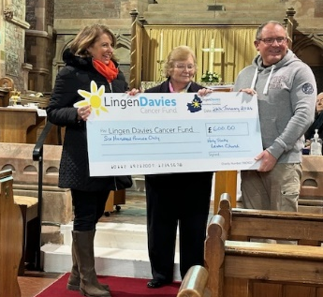
Charitable donations from the Christmas Tree Festival
Thanks was expressed to all those at Holy Trinity Leaton after their Christmas Tree Festival raised £600 for Lingen Davies. Here is Angela from the charity receiving a cheque at our Candlemas service.

PANTOMIME THANK YOU
from the Churches, Parish Hall and Social Committees at Montford and Shrawardine

A huge thank you to everyone who was involved in any way with this year’s production of Mother Goose. You all know who you are and the Parish Hall and Social Committees are indebted to you for the amount of time and effort put in beforehand and/or on the days.

Monies raised (as yet not finalised) will be divided between Montford and Shrawardine Churches (thank you!!) and the Hall, while the raffle and some sponsorship will be put towards a defibrillator for the Parish Hall.

Here is a wonderful critique from Guy on the Friday performance:

After 11 years of the classics Severn Loop Players took on perhaps the hardest Panto of all, Mother Goose, which mops up all the remaining fairy tale characters and challenges the Panto world to give us a great night out.

I’m pleased to report in true style SLP pulled it off. Like a box of Quality Street, before us unwrapped a delicious variety of colourful characters, each with a distinct flavour that all together gave us a Panto triumph.

Why are SLP complimented with full houses each year? The answer is how well each element of the Panto experience is done, from our compere who lowers our expectations beautifully, the personality put into the music, transformative stage sets, imaginative costumes and great fun makeup. Wrapped up in a script written for the characteristics of each actor, where ad libs and the written lines are seamlessly blended, although clearly no one told the curtain operators!

So once again we had strong performances from all the main characters. Starting with the ying and yang of Hansel and Gretel. The thoughtful drawl of the big, bad wolf who clearly feels he’s just misunderstood and is probably a closet vegetarian, who never really stood a chance against a Goldilocks fresh off the “made in Chelsea” set. We actually felt sorry for the wicked witch who excellently bemoaned her change of part to the dark side. The lost innocence of little Red Riding Hood, who is portrayed by an actor clearly in love with drag and thoroughly enjoying the innuendo of a woodsman and her chopper.
Add in the wider cast of well-acted fairyland characters ranging from goblins, Easter fairy and her Bunny, to the inexplicable arrival of dancing flamingos that SLP is famous for. All these disparate characters are held together by the flamboyance of our Geordie mother goose, whose twerking bottom safely leads us to a happy ending.
The standout scene was the Three Bears, where Pythonesque 'don't mess with me' mother bear, her hapless daddy bear and spoilt baby bear take us beautifully through the simple much-loved story of porridge, chairs and beds. A credit to all things Panto.
Where SLP go from here we don't know but the obvious happiness in their rendition of 'don't stop me now, we're having a great time' clearly showed. It will be worth waiting for!

Readings for February

Date | Psalm | First Reading | Second Reading/ Gospel
4th February | 104. 26-37 | Proverbs 8.1,22-31 | John 1.1-14
11th February | 50.1-6 | 2 Kings 2.1-12 | Mark 9.2-9
14th February  Ash Wednesday | Psalm 51.1-18 | Joel 2.1-2,12-17 | John 8.1-11
18th February | 25.1-9 | Genesis 9.8-17 | Mark 1.9-15
25th February | 22.23-31 | Genesis 17.1-7,15,16 | Mark 8.31-38
3rd March | 19 | Exodus 20.1-17 | John 2.13-22

SUNDAY SERVICES FOR FEBRUARY 2024

 | Albrighton | Bicton | Bomere  Heath | Fitz | Leaton | Montford | Shrawardine
4th February  2nd before Lent  Green | 9.15 am  HC | 11 am  HC |  | 9.30 am  HC | 10.45 am  HC  (in the Mission Church) |  | 9.30 am  MP
11th February  Sunday before Lent  Green |  | 11 am  MP | 9 am  HC |  | 10.45 am  MP  (in the Mission Church) | 9.30 am  HC | 11 am  HC
14th February  Ash Wednesday  Purple |  | 11.30am
18th February  Lent 1  Purple | 9.15 am  MP | 11 am  HC |  | 9.30 am  HC | 10.45 am  HC (in the Mission Church) | 9.30 am  MP
25th February  Lent 2  Purple | 3pm Forest Church Huffley | 11 am  MP | 9 am  HC |  | 10.45 am  MP (in the Mission Church) | 11 am  HC | 9.30 am  HC
3rd March  Lent 3  Purple | 9.15 am  HC | 11 am  HC |  | 9.30 am  HC | 10.45 am  HC (back at Leaton) |  | 9.30 am  MP

HC- Holy Communion; MP- Morning Prayer

OTHER WAYS TO WORSHIP ON SUNDAYS
SUNDAY AT SIX 6 pm via Zoom – email Peter or Hannah to receive the link.
SHARING THE LIGHT IN THE LOOP- weekly phone line worship – see top of this page for the number.
DAILY HOPE – national phone line, see number above.
LICHFIELD CATHEDRAL- www.lichfield-cathedral.org 10.30 am Eucharist

