Priest-in-Charge: The Revd Hannah Lins
07736 012011 revhannahlins@gmail.com
Assistant Priest: The Revd Peter Allan
www.severnloopparishes.org.uk 01939 290048 pallan412@gmail.com
Loop Safeguarding Officer: Mrs Philippa Herbert 01939 291352 Lay Pastoral Minister: Mrs Joyce Jagger
Sharing the Light in the Loop 01743 298285 weekly worship 07802 695954 pearhill1@outlook.com
Daily Hope – the national service 0800 804 8044
APRIL LOOP 2024
Weekly Collects, Readings and Reflection are on the website (see above.)

Forest Church
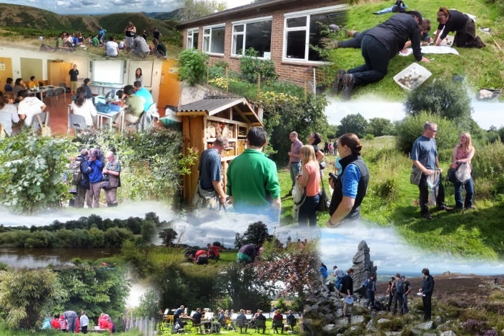
We had a lovely time at Huffley back in February- the lambs were plentiful, and a delight! There was also a big barn housing the ‘waiting’ sheep- those who were heavily pregnant and almost ready to give birth. There was something so peaceful about that space- many of us enjoyed being in there and feeling the sense of calm focus. All in all, it was a lovely afternoon, and we’re very grateful to those who manage the farm who were so generous with their time and space.

The next Forest Church will be on Sunday, 14th April at 3pm at Preston Montford Field Studies Centre. This is a new venue for us, and we’re very excited! Sue Dancey will be running the afternoon (with help from a few others)- there will be plenty of activities to join in with, all with a geographical/ botanical/ ecological feel- to help us understand more of the complex, interconnected natural systems that we are part of. The centre have been very kind in allowing us access- so do please come along and enjoy the afternoon. If the weather is inclement then there are indoor spaces we can use as well.

Evensong at Fitz- an opportunity to join in

As summer threatens to unfold (!) we are going to have a one-off Evensong service at Fitz, followed by refreshments- 21st April, 6pm. Please do feel warmly invited to come along.

With that in mind, perhaps you’d like to join the pop-up choir?! It was wonderful to have a strong choir for our Candlemas service, and it really helps the congregation feel confident in joning in with the sung parts of the service. If you would like to be part of the choir, we have two rehearsals- 6pm on Thursday, 18th April and 4.45pm on Sunday, 21st April (running straight into the service). As long as you can make at least one of them, you’re in! Do contact Hannah or Peter if you are interested. Thank you.

Clergy Conference
Hannah will be away at the Clergy Conference from the 22nd to 25th April.
.

Afternoon Tea for Ladies
At the Mission Church in Bomere Heath

Saturday April 20th 3pm -5pm.
SPEAKER Revd. Hannah Lins

Tickets £5 from Pat Hall 01939 290637 or Valerie Rennie 01939 290604

Diary Dates
Bicton CAMEO Coffee Morning- 11th April, 10.30am- noon. In church.
The Stepping Out Café in Bomere Heath- 24th April, 2.30pm-4pm, Mission Church
Filling Station- Knockin Village Hall is on 16th April, 7.10pm for a 7.30pm start. The next one at Rodington Village Hall (SY4 4QS) is on 22nd April 2024, 7.15pm for a 7.30pm start.
POSTPONED: Wine, Canapés and pre-loved clothes- this was publicised as happening on 12th April, but has now been postponed until the 31st August. Details to follow nearer the time.

Service Cover in April, and APCM talks
We’re very grateful to Revd. Fi Iddon and Revd. Andy Ackroyd who will be covering services at Bomere and Bicton on 28th April.

Our annual meetings always end with a talk from me, sharing encouragements from around Severn Loop. So that as many people as possible can hear about how God has been at work in our parishes over the past year, I’m going to give the APCM talk in place of the homily on Sunday mornings throughout April and May- on the following dates:
7th April- Albrighton and Leaton
14th April- Bomere and Bicton
21st April- Montford (Joint service where Shrawardine attend)
5th May- Fitz

APCMs
Our Annual Parochial Church Meetings (APCMs) are open to all and this year will be held as follows:

Bicton - Friday, 26th April, 2pm
Albrighton - Monday, 29th April, 2pm
Fitz - Monday, 29th April, 7pm
Leaton - Tuesday, 30th April, 7.15pm
Montford & Shrawardine - Wednesday, 8th May, 7.15pm

For Your Prayers
- For the people of Israel and Palestine and the people of Ukraine- for peace.
- For all those preparing for Baptism or to be married- the wedding season is nearly upon us.
- For those who depend on the health of the land for their livelihood.
- For those in hospital, and for our NHS.
- For our local schools.
- For all who mourn, including the family and friends of Clare Lea and Harry Sheehan.
- For the Royal Family, and all who are living with a cancer diagnosis.

Readings for April
Date | Psalm | First Reading | Second Reading/ Gospel
7th April  Easter 2, white | 133 | Acts 4.32-35 | John 20.19-31
14th April  Easter 3, white | 4 | Acts 3.12-19 | Luke 24.36b-48
21st April  Easter 4, white | 23 | Acts 4.5-12 | John 10.11-18
28th April  Easter 5, white | 22.25-31 | Acts 8.26-40 | John 15.1-8
5th May  Easter 6, white | 98 | Acts 10.44-48 | John 15.9-17

SUNDAY SERVICES FOR APRIL 2024

 | Albrighton | Bicton | Bomere  Heath | Fitz | Leaton | Montford | Shrawardine
7th April | 9.15 am  HC | 11 am  HC |  | 9.30 am  HC | 10.45 am  HC |  | 9.30 am  MP
14th April |  | 11 am  MP  3pm Forest Church Preston Montford | 9 am  HC |  | 10.45 am  MP | 9.30 am  HC | 11 am  HC
21st April | 9.15 am  MP | 11 am  HC |  | 6pm Evensong | 10.45 am  HC | 9.30 am  MP
28th April |  | 11 am  MP | 9 am  HC |  | 10.45 am  MP | 11 am  HC | 9.30 am  HC
5th May | 9.15am  HC | 11am  HC |  | 9.30am  HC | 10.45am  HC |  | 9.30am  MP

HC- Holy Communion; MP- Morning Prayer

OTHER WAYS TO WORSHIP ON SUNDAYS
SUNDAY AT SIX 6 pm via Zoom – email Peter or Hannah to receive the link.
SHARING THE LIGHT IN THE LOOP- weekly phone line worship – see top of this page for the number.
DAILY HOPE – national phone line, see number above.
LICHFIELD CATHEDRAL- www.lichfield-cathedral.org 10.30 am Eucharist

