|  |  |  |
| --- | --- | --- |
| **Priest in Charge:** | Revd Hannah Lins | [revhannahlins@gmail.com](mailto:revhannahlins@gmail.com), 07736 012011 |
| **Assistant Priest:** | Revd Peter Allan | [pallan412@gmail.com](mailto:pallan412@gmail.com), 01939 290048 |
| **Pastoral Minister:** | Mrs Joyce Jagger | [pearhill1@outlook.com](mailto:pearhill1@outlook.com), 07802 695954 |
| **Safeguarding Officer:** | Mrs Philippa Herbert | 01939 291352 |
| **Administrator:** | Miss Rosie Dixon | [severn.loopparishes@gmail.com](mailto:severn.loopparishes@gmail.com) |
| **Daily Hope (the national phoneline service)** | | 0800 8048044 |
| *Weekly Collects, readings and reflections are on the website-* [*www.severnloopparishes.org.uk*](http://www.severnloopparishes.org.uk) | | Dementia Action Week at Somerset Museums – South West Heritage Trust |

**MARCH LOOP 2025**

**‘Looking after each other’ lunch**

A substantial group of us met at the Mission Church last Sunday for lunch together. We spent a little time thinking about the pastoral care networks around the Loop, and how we care for each other in our church congregations. Actually though, we spent most of the time chatting and eating! We’re deeply grateful to Joyce for sorting out the main course, and for everyone there who mucked in helping in the kitchen and to tidy-up afterwards. We agreed that it would be a really good thing to do on a regular basis- both to build up relationships between congregations and to welcome new folk. Expect another date before too long!

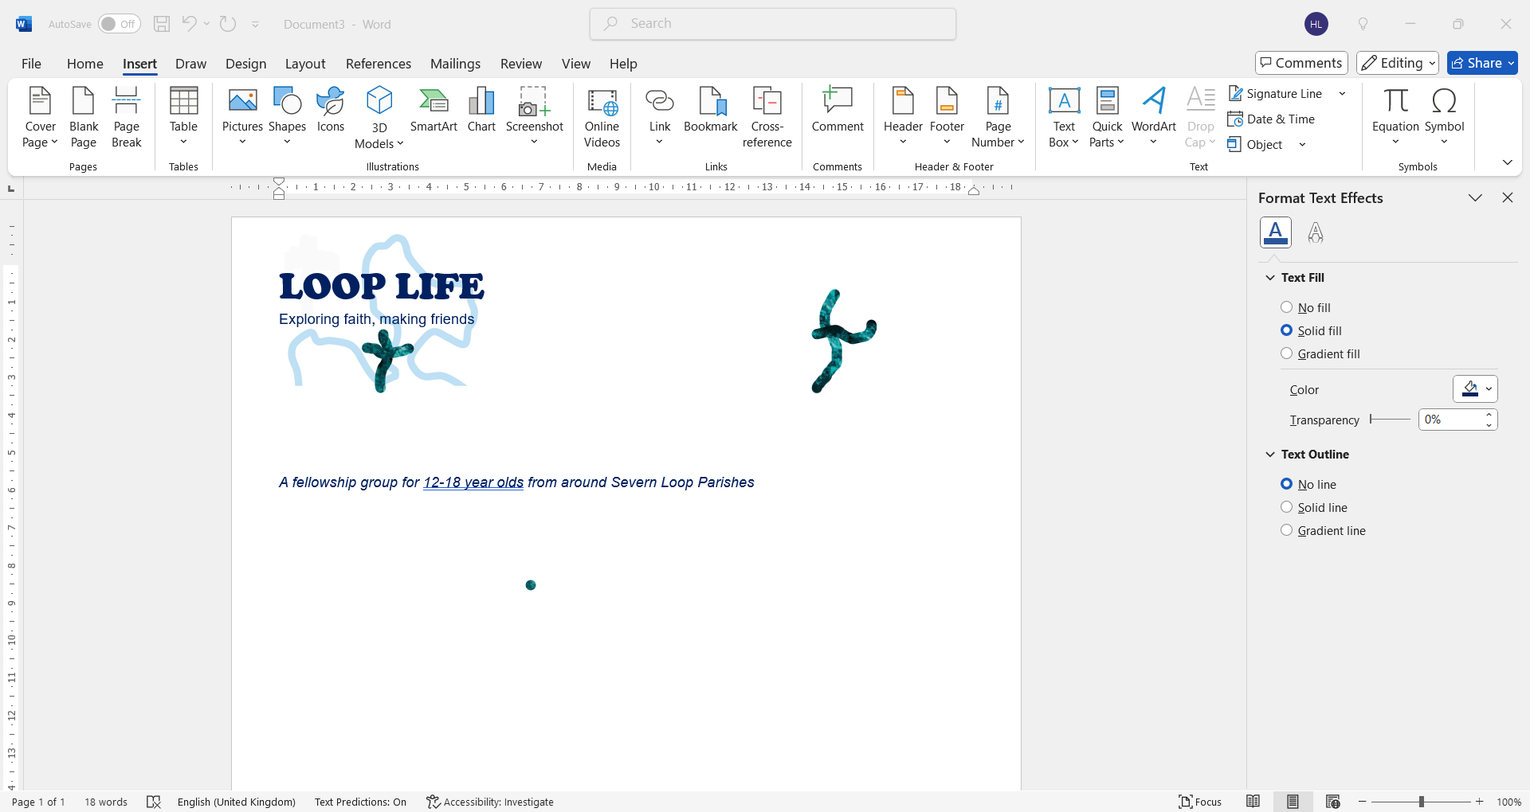**Introducing Loop Life**

We are delighted to be starting a group for young people of secondary school age (years 7-13). Anyone (in that age range!) is most welcome. *Loop Life* will meet at the Rectory in Bicton, 7pm-8pm, on:

**13th March 27th March 1st May 22nd May**

**12th June 26th June 10th July**

We will have hot chocolate and cream (obligatory!), get to know each other, have some fun games and engage with the Bible and prayer. It’ll be a chance for young people to explore faith, deepen friendships and be a source of support for each other. So far, three young people have indicated that they will come along- we’d really, really love a few more! I’m also really pleased that Natalie Johnson has agreed to be our second adult.

**Cricket Bat Willow and help with mowing**

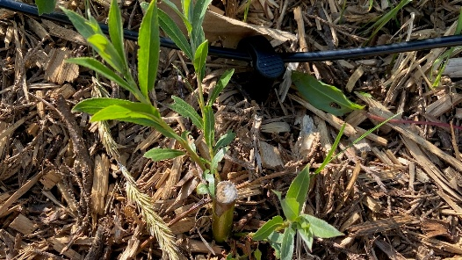At Leaton, we are going to introduce some Cricket Bat Willow at the bottom of the churchyard, in the hope that it will take up some of the moisture in the ground. If you have any Cricket Bat Willow saplings that you’d be willing to donate, please let me know by 15th March (I can come and pick them up). We’d be very grateful!

Also at Leaton, we’d love a few more people to go on the lawnmowing rota. There are two lovely machines, full training is provided, and people are always paired up, so you will have company! Do let Peter Leddington know if you’re interested- [p.leddington@outlook.com](mailto:p.leddington@outlook.com).

**The Common Cup**

We’ve recently been reminded at General Synod of the Church of England rules around communion. Once again, please can we reiterate that intincting (dipping the wafer in the wine) is not permitted- communion can be taken in one kind only, or with the common cup. We’re certainly heading in the right direction as a parish, but it would be great if we could get back to how things were before Covid! I’m particularly mindful that I’m putting visiting clergy in an awkward position because I’m asking them to accept something that is outside canon law when they take services in the parish.

**Count me in!**

This year the Electoral Roll is being completely revised, so everyone will be asked to join again. The Electoral roll is a really important way of saying “I belong” to the life of the church, both locally and nationally. It seeks to be an indication of the strength of church life, recording the amazing family of God who make up churches across England seeking to be a Christian presence in every community.

Joining the electoral roll also opens up the way for greater involvement in the life of the church, at deanery, diocesan and national events. You become entitled to vote at the Annual Parish Church meeting, and become eligible to join the church committees and PCC. I’ve attached a copy of the Electoral Roll with this email, and each congregation has an officer, who collates the information- so do return it to them (as below):

*Albrighton with Battlefield- Tom Higgins*

*Bicton- Clare Dixon*

*Fitz- Peter Malpass*

*Leaton and Bomere Heath- Philippa Herbert*

*Montford and Shrawadine- Jill Mace*

**Frequently asked questions:**

***Do I have to join the electoral roll to come to church?***

No, everyone is always welcome. But good pastoral work is supported by good administration, and so part of being a caring church and a growing church is to know “who belongs where”.

***I’ve filled in the electoral roll form before. Do I have to complete it again?***

The roll is completely revised every six years, so yes, you will need to complete it again this year.

***I have children. Where do they fit into all of this?***

Children and young people are an integral part of the life of the church. If you are over 16, or turning 16 over the course of this next year, you’re able to join the electoral roll.

**Forest Church**

Our next Forest Church will be on 27th of April 3-6pm at Shrawardine, with a mini-pilgrimage to Montford for those who like to walk! Details in next month’s Loop.

**Deanery Synod**

In the Loop we very much appreciate that we are always part of something bigger- the next level up from our parishes is Deanery Synod. This is a meeting of local *Church of England* churches, covering the Shrewsbury and Wrockwardine areas. Back in the day (!) I used to be the secretary of the Synod, and I remember that Severn Loop were the best attenders! These days though, we could really do with a few more synod representatives. The commitment is three meetings per year, in different venues around the area. The meetings are open, so if you’d like to find out more, do come along to the next one. I’ll be co-leading it, and the topic is care for creation- a fundamental aspect of our vocation as Christians. It’s on Tuesday, 18th March, 7pm for 7.30pm, Holy Trinity, Meole Brace.

**Soup Lunch on Ash Wednesday**

If you would like to stay for lunch after the Ash Wednesday service on 5th March at Bicton, do let Wendy Horan know, so we can make sure there’s plenty of soup (01743 850237).

**Diary Dates**

**CAMEO Coffee Morning at Bicton Church –** 13th March, 10.30am-11.30am.

**The Stepping Out Café in Bomere Heath-** 26th March, 2.30pm-4pm.

**Filling Station**- Knockin Village Hall is on 18th March, 7.10pm for a 7.30pm start. The next one at Rodington Village Hall (SY4 4QS) is on 24th March 2025, 7.15pm for a 7.30pm start.

**REVS-** Saturday, 15th March, 10am-noon, Holy Trinity, Leaton.

**Readings for March**

|  |  |  |  |
| --- | --- | --- | --- |
| **Date** | **Psalm** | **First Reading** | **Second Reading/ Gospel** |
| 2nd March  Sunday before Lent, green | Psalm 99 | Acts 13. 46-49 | Matthew 9. 35-38 |
| 5th March  Ash Wednesday, purple | Psalm 51. 1-18 | 2 Corinthians 5. 20b - 6.10 | Matthew 6. 1-6, 16-21 |
| 9th March  Lent 1, purple | Psalm 91. 1-2,  9-16 | Romans 10. 8b-13 | Luke 4. 1-13 |
| 16th March  Lent 2, purple | Psalm 27 | Philippians 3. 17-4.1 | Luke 13. 31-35 |
| 23rd March  Lent 3, purple | Psalm 63. 1-9 | 1 Corinthians 10. 1-13 | Luke 13. 1-9 |
| 30th March  Mothering Sunday, purple | Psalm 34. 11-20 | Colossians 3. 12-17 | Luke 2. 33-35 |
| 6th April  Lent 5, purple | Psalm 126 | Philippians 3. 4b-14 | John 12. 1-8 |

**SUNDAY SERVICES FOR MARCH 2025**

|  |  |  |  |  |  |  |  |
| --- | --- | --- | --- | --- | --- | --- | --- |
|  | **Albrighton** | **Bicton** | **Bomere**  **Heath** | **Fitz** | **Leaton** | **Montford** | **Shrawardine** |
| **2nd March** |  |  |  |  |  | United service 10.30am |  |
| **5th March** |  | 11.30am  Service with ashing |  |  |  |  |  |
| **9th March** |  | 11 am  MP | 9 am  HC |  | 10.45 am  MP | 9.30 am  HC | 11 am  HC |
| **16th March** | 9.15 am  MP | 11 am  HC |  | 9.30 am  HC | 10.45 am  HC | 9.30 am  MP |  |
| **23rd March** |  | 11 am  MP | 9 am  HC |  | 10.45 am  MP | 11 am  HC | 9.30 am  HC |
| **30th March** | 9.15 am  HC | 11 am  HC |  | 9.30 am  HC | 10.45 am  HC |  | 9.30 am  MP |
| **6th April** | 9.15am  HC | 11am  HC |  | 9.30am  HC | 10.45am  HC |  | 9.30am  MP |

***HC- Holy Communion; MP- Morning Prayer***

**OTHER WAYS TO WORSHIP ON SUNDAYS-** SUNDAY AT SIX 6 pm via Zoom – email Peter or Hannah to receive the link.DAILY HOPE – national phone line, see number above.LICHFIELD CATHEDRAL- www.lichfield-cathedral.org 10.30 am Eucharist

**For Your Prayers**

* For peace.
* For the recently bereaved, especially the family and friends of Peter Williams, Graham Hanmer and Barbara Barkley.
* For Forest Church and our ministry to children- especially our new group.
* For those in hospital, and for our NHS.

