**COLLECT, READINGS AND REFLECTION**

**SUNDAY 13 APRIL 2025 – Palm Sunday**

**COLLECT**

Almighty and everlasting God,

who in your tender love towards the human race

sent your Son our Saviour Jesus Christ

to take upon him our flesh

and to suffer death upon the cross:

grant that we may follow the example of his patience and humility,

and also be made partakers of his resurrection;

through Jesus Christ your Son our Lord,

who is alive and reigns with you,

in the unity of the Holy Spirit,

one God, now and for ever.

**Psalm 118. 1-2, 19-29**

1 O give thanks to the Lord, for he is good;  ♦

his mercy endures for ever.

2 Let Israel now proclaim,  ♦

‘His mercy endures for ever.’

19 Open to me the gates of righteousness,  ♦

that I may enter and give thanks to the Lord.

20 This is the gate of the Lord;  ♦

the righteous shall enter through it.

21 I will give thanks to you, for you have answered me  ♦

and have become my salvation.

22 The stone which the builders rejected  ♦

has become the chief cornerstone.

23 This is the Lord’s doing,  ♦

and it is marvellous in our eyes.

24 This is the day that the Lord has made;  ♦

we will rejoice and be glad in it.

25 Come, O Lord, and save us we pray.  ♦

Come, Lord, send us now prosperity.

26 Blessed is he who comes in the name of the Lord;  ♦

we bless you from the house of the Lord.

27 The Lord is God; he has given us light;  ♦

link the pilgrims with cords

right to the horns of the altar.

28 You are my God and I will thank you;  ♦

you are my God and I will exalt you.

29 O give thanks to the Lord, for he is good;  ♦

his mercy endures for ever.

**A reading from the letter to the Philippians, chapter 2, verses 5-11.**

## **Philippians 2. 5-11**

Let the same mind be in you that was in Christ Jesus,  
who, though he was in the form of God,  
did not regard equality with God  
as something to be exploited,  
but emptied himself,  
taking the form of a slave,  
being born in human likeness.  
And being found in human form,  
he humbled himself  
and became obedient to the point of death—  
even death on a cross.

Therefore God also highly exalted him  
and gave him the name  
that is above every name,  
so that at the name of Jesus  
every knee should bend,  
in heaven and on earth and under the earth,  
and every tongue should confess  
that Jesus Christ is Lord,  
to the glory of God the Father.

This is the word of the Lord.

**Thanks be to God.**

***At Morning Prayer, the Gospel is simply the second reading, people sit to hear it and is introduced in the same way as the first:***

The second reading is from Luke, chapter 2, verses 33-35.

***and then at the end:***

For the word of the Lord

**Thanks be to God.**

***For Eucharists/ Communion people stand to hear the Gospel. Everywhere except Fitz introduces it with an Acclamation (the blue bit), and then we all use the introduction and ending (the green bit):***

Praise to you, O Christ, King of eternal glory.

**Praise to you, O Christ, King of eternal glory.**

I am the light of the world, says the Lord,

whoever follows me will have the light of life.

**Praise to you, O Christ, King of eternal glory.**

Hear the Gospel of our Lord Jesus Christ, according to Luke, Chapter 2, verses 33-35.

**Glory to you, O Lord**

***And then at the end:***

This is the Gospel of the Lord.

**Praise to you, O Christ.**

## **Luke 19. 28-40**

## **Jesus’ Triumphal Entry into Jerusalem**

After he had said this, he went on ahead, going up to Jerusalem.

When he had come near Bethphage and Bethany, at the place called the Mount of Olives, he sent two of the disciples, saying, ‘Go into the village ahead of you, and as you enter it you will find tied there a colt that has never been ridden. Untie it and bring it here. If anyone asks you, “Why are you untying it?” just say this: “The Lord needs it.” ’ So those who were sent departed and found it as he had told them. As they were untying the colt, its owners asked them, ‘Why are you untying the colt?’ They said, ‘The Lord needs it.’ Then they brought it to Jesus; and after throwing their cloaks on the colt, they set Jesus on it. As he rode along, people kept spreading their cloaks on the road. As he was now approaching the path down from the Mount of Olives, the whole multitude of the disciples began to praise God joyfully with a loud voice for all the deeds of power that they had seen, saying,  
‘Blessed is the king  
who comes in the name of the Lord!  
Peace in heaven,  
and glory in the highest heaven!’  
Some of the Pharisees in the crowd said to him, ‘Teacher, order your disciples to stop.’ He answered, ‘I tell you, if these were silent, the stones would shout out.’

***A Reflection from Hannah… sort of!***

As we begin Holy Week together, our reading from Philippians is a salutary reminder of the ‘emptying’ of Christ, to become the Servant King. As an offering to ponder, this picture (below) by Vincent Van Gogh is a meditation on that passage, and is followed by a commentary by Joanna Collicutt:

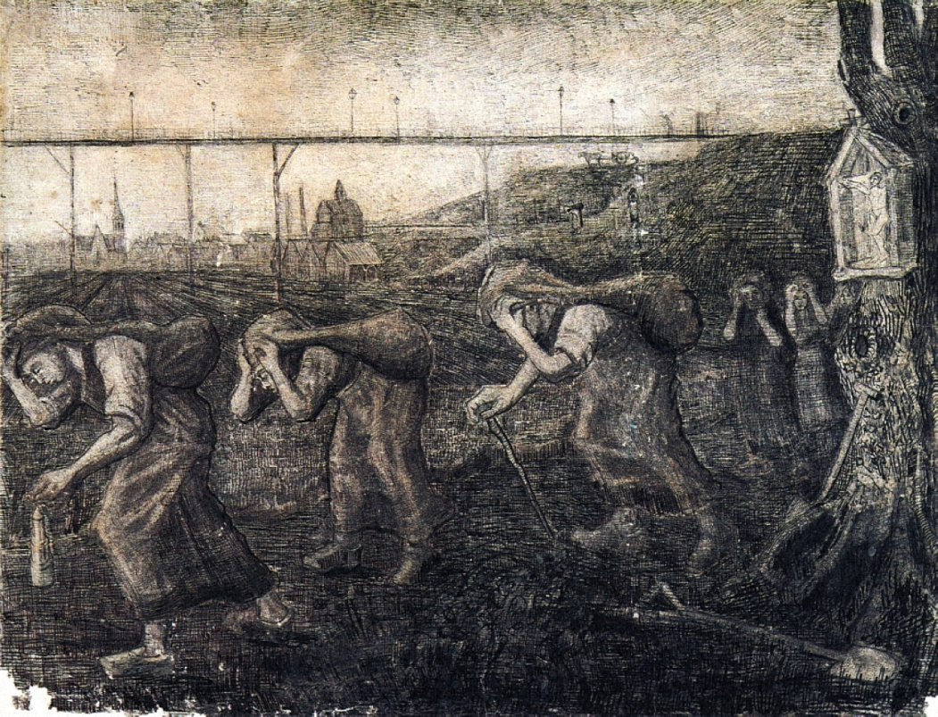

Vincent van Gogh has been described as displaying a ‘passionate identification with Christ’ throughout his life (Pritchard 1971: 15), but most intensely in the years immediately preceding his emergence as an artist. Having undertaken theological studies, he was appointed as a lay pastor in the impoverished mining district of Borinage in Belgium in 1879. Van Gogh was obsessed with following Christ in his solidarity with those who serve, and for some months lived in a miner’s hut, not counting entitlement to the pastor’s lodgings ‘a thing to be grasped’ (Philippians 2:6). He even went down into the dangerous Marcasse mine. Later he would describe this as ‘the depth of the abyss’ (Van Gogh 1978: 200). Like Christ, he had descended. Not long after, having been dismissed from his position, he again modelled himself on Christ: ‘I shall rise again: I will take up my pencil…’ (Van Gogh 1978: 136). Here we see the result.

As in so many societies, the labour of women involves transporting heavy loads (children, water, crops). Here they are bent double under sacks of coal gleaned from slag-heaps to burn in their homes. The simple documentation of their work can be seen as a redemptive artistic action expressing Van Gogh’s continuing aspiration to the mind of Christ.

But there is more; the original English title almost certainly alludes to Matthew 23:4 where Jesus denounces the religious leaders for laying heavy burdens on ordinary people. The viaduct in the distance is a triumphant monument to the industry that determines the lives of the women. Behind it, separated from their world of servitude but benefiting from it, stand a Protestant and a Catholic church; these women are at once abandoned and oppressed by the hypocrisy of institutional religion.

This, we are reminded, was also true of Christ Jesus, for hanging in the right foreground we see him who ‘became obedient unto death … on a cross’ (Philippians 2:8), bearing the burden of the world, in deep solidarity with suffering humanity.