|  |  |  |
| --- | --- | --- |
| **Priest in Charge:** | Revd Hannah Lins | [revhannahlins@gmail.com](mailto:revhannahlins@gmail.com), 07736 012011 |
| **Assistant Priest:** | Revd Peter Allan | [pallan412@gmail.com](mailto:pallan412@gmail.com), 01939 290048 |
| **Pastoral Minister:** | Mrs Joyce Jagger | [pearhill1@outlook.com](mailto:pearhill1@outlook.com), 07802 695954 |
| **Safeguarding Officer:** | Mrs Philippa Herbert | 07871 865253 |
| **Administrator:** | Miss Rosie Dixon | [severn.loopparishes@gmail.com](mailto:severn.loopparishes@gmail.com) |
| **Daily Hope (the national phoneline service)** | | 0800 8048044 |
| *Weekly Collects, readings and reflections are on the website-* [*www.severnloopparishes.org.uk*](http://www.severnloopparishes.org.uk) | | Dementia Action Week at Somerset Museums – South West Heritage Trust |

**APRIL LOOP 2025**

**Hope- filled? Be part of our Festival of Hope!**

**27th April- 11th May**

**‘Hope-filled’- online gallery**

How do you express hope? If you have a craft project, Easter display or photo that gives you hope or communicates encouragement, we'd love to add it to our gallery! We are creating an online exhibition of hope-filled images from folk around Severn Loop. If you'd like to be part of it, send us a picture (in landscape orientation), along with your name and a brief description- and we will incorporate it as appropriate. To take a look, go to [Photos - Severn Loop Parishes](https://severnloopparishes.org.uk/photos/gallery.php?id=17). Send entries to [severn.loopparishes@gmail.com](mailto:severn.loopparishes@gmail.com).

**Stations of the Resurrection pilgrimage**

Come on a pilgrimage around Severn Loop Parishes! In any order, taking one day or many… each of our churches/ churchyards will have a creative depiction of one of the resurrection stories of Jesus- stories that give us hope in God who continues to transform lives today. Whether it’s in the small moments, like the confusion of Mary Magdalene as she peered into an empty tomb; or the enormous moments, like the birth of the Church at Pentecost as God’s Spirit filled the people and continues to fill them today; we hope that in each of our displays you will find something that matters, that encourages you and that changes you as you journey onwards.

Shrawardine, Montford, Preston Gubbals and Battlefield will have displays in the church buildings. Bicton, Fitz, Leaton and Albrighton will have displays in the churchyards or church porches. To download a *Pilgrim Passport* and map with parking tips, go to <https://severnloopparishes.org.uk/news-and-events/> from April onwards. *Suitable for all ages.*

**Celebration Events**

***Forest Church-*** *Sunday, 27th April, 3pm-6pm*

Church in the open air! Time for exploring, and a mini-pilgrimage from Shrawardine to Montford (about 1.5 miles), where we will have a celebration service. Beginning at Shrawardine, we will have some time to explore nature before heading over the bridleway to Montford, where we will have a short outdoor service. Do bring a packed-tea if you’d like to.

***Concert @Leaton Church-*** *Sunday, 4th May, 3pm*

Come and enjoy music from *The Ronnies* (a singing group who specialise in WWII music) as we recall the 80th anniversary of VE Day. There is no charge (donations are welcome). Just turn up, but if you do know you are coming please email [severn.loopparishes@gmail.com](mailto:severn.loopparishes@gmail.com), or phone 01939 290637 as that will help us with catering.

***Songs of Praise @Bicton Church-*** *Sunday, 11th May, 5pm*

With stories of hymns that gave us strength in difficult times. If you have a story, or a favourite hymn, email [revhannahlins@gmail.com](mailto:revhannahlins@gmail.com). This will be our festival finale!

**Holy Week and Easter**

Join us on Maundy Thursday, Good Friday and Easter Day- service times and details are at the end of the Loop. Just to be clear, all are welcome at Battlefield, 5.30am!

**APCM Meetings**

Our annual meetings are coming up in April and May. This is a chance to celebrate all that’s going on around Severn Loop and to hear reports from those involved in various ministries in our churches. As last year, I will be giving my review of the year talk as a homily in our morning services. Here are the dates and times:

|  |  |  |
| --- | --- | --- |
| **Parish** | **APCM date and time** | **Date of the Priest in Charge report (given in a Sunday service)** |
| Leaton | 3rd April, 7.15pm, Mission Church | 11th May at Bomere  18th May at Leaton |
| Albrighton | 10th April, 2pm | 18th May |
| Montford and Shrawardine | 10th April, 7.15pm, Shrawardine | 27th April at Montford and Shrawardine |
| Bicton | 1st May, 1.30pm | 4th May |
| Fitz | 8th May, 6pm | 4th May |

**Forest Church**

Our next Forest Church will be on 27th of April 3-6pm at Shrawardine, details above!

**Confirmation**

We are delighted that Bishop Michael will be coming to do confirmations on 7th September, 5pm. We are on the look-out for candidates! If you are aged between 10 and 100+, have never been confirmed and would like to make this commitment to the Christian faith, please let me know! We are asking children in the local schools as well, and we have at least one adult in the Loop who has put their name forward- which is very exciting. Please keep all the potential candidates in your prayers.

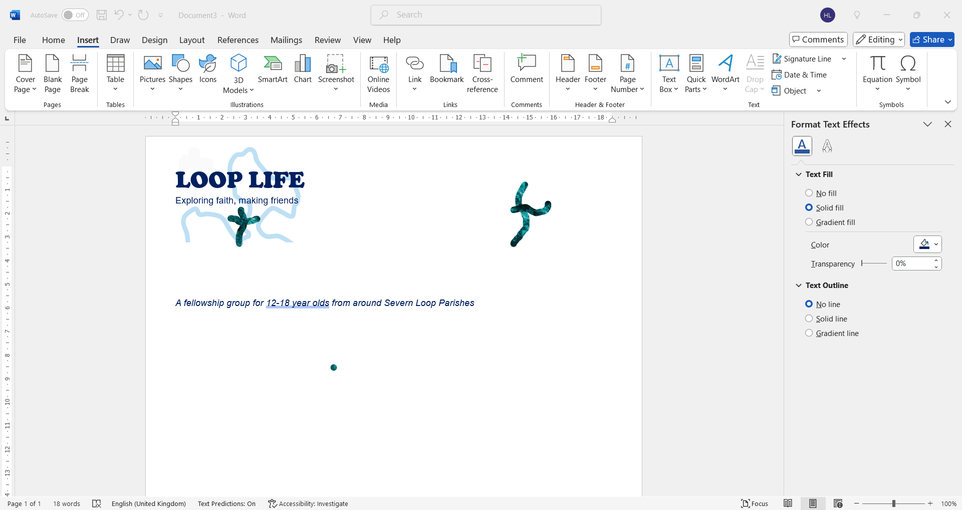Loop Life has got off to a lovely start! We’ve met twice so far, and explored a different Bible story each time. Young people aged between 11-18 (years 7 to 13) are most welcome- please do keep spreading the word. We are hoping eventually to meet twice a month, but diary commitments in April mean that our next meeting will be on **1st May, 7pm, The Rectory in Bicton.**

**Diary Dates**

**CAMEO Coffee Morning at Bicton Church –** 10th April, 10.30am-11.30am.

**The Stepping Out Café in Bomere Heath-** 30th April, 2.30pm-4pm

**Filling Station**- Knockin Village Hall is on 15th April, 7.10pm for a 7.30pm start. The next one at Rodington Village Hall (SY4 4QS) is on 28th April 2025, 7.15pm for a 7.30pm start.

**REVS-** Saturday, 19th April, 10am-noon, Holy Trinity, Leaton.

**For Your Prayers**

* For our local farmers.
* For peace.
* For the recently bereaved, especially the family and friends of Glynne Price.
* For our Festival of Hope.
* For those in hospital, and for our NHS.
* For those preparing for baptism.
* For those preparing for marriage- particularly Gemma and George who are getting marrig on 17th April.

**Common Cup**

Thank you all for adapting so well to our request that we get back within Canon Law in the way we administer communion- we are very grateful!

**Readings for April**

|  |  |  |  |
| --- | --- | --- | --- |
| **Date** | **Psalm** | **First Reading** | **Second Reading/ Gospel** |
| 6th April,  Lent 5, purple | Psalm 126 | Philippians 3. 4b-14 | John 12. 1-8 |
| 13th April  Palm Sunday, red | Psalm 118. 1-2, 19-29 | Philippians 2. 5-11 | Luke 19. 28-40 |
| 17th April  Maundy Thursday, white then stripped | Psalm 116.1,10-end | 1 Corinthians 11.23-26 | John 13.1-17,31b-35 |
| 18th April  Good Friday, stripped | Psalm 22 | Hebrews 10.16-25 | John 18.1 - 19.42 |
| 20th April  Easter Day, white | Psalm 118. 1-2, 14-24 | Acts 10. 34-43 | John 20. 1-18 |
| 27th April,  Easter 2, white | Psalm 150 | Acts 5. 27-32 | John 20. 19-31 |
| 4th May,  Easter 3, white | Psalm 30 | Acts 9. 1-6 | John 21. 1-19 |

**SUNDAY SERVICES FOR APRIL 2025**

|  |  |  |  |  |  |  |  |
| --- | --- | --- | --- | --- | --- | --- | --- |
|  | **Albrighton** | **Bicton** | **Bomere**  **Heath** | **Fitz** | **Leaton** | **Montford** | **Shrawardine** |
| **6th April** | 9.15 am  HC | 11 am  HC |  | 9.30 am  HC | 10.45 am  HC |  | 9.30 am  MP |
| **13th April** |  | 11 am  MP | 9 am  HC |  | 10.45 am  MP | 9.30 am  HC | 11 am  HC |
| **17th April** |  | 7pm Eucharist | 7pm Agape Meal |  |  |  |  |
| **18th April** |  | 2pm  Last Hour | 2pm  Last Hour |  |  |  |  |
| **20th April** | Battlefield sunrise- 5.30am  9.15 am  HC | 11.15 am  HC | 8am  HC | 10.15 am  HC | 10.45 am  HC | 9am  HC | 8am  HC |
| **27th April** |  | 11 am  MP | 9 am  HC |  | 10.45 am  MP | 11 am  HC | 9.30 am  HC  3pm Forest Church |
| **4th May** | 9.15 am  HC | 11 am  HC |  | 9.30 am  HC | 10.45 am  HC |  | 9.30 am  MP |

***HC- Holy Communion; MP- Morning Prayer***

**OTHER WAYS TO WORSHIP ON SUNDAYS-** SUNDAY AT SIX 6 pm via Zoom – email Peter or Hannah to receive the link.DAILY HOPE – national phone line, see number above.LICHFIELD CATHEDRAL- www.lichfield-cathedral.org 10.30 am Eucharist

