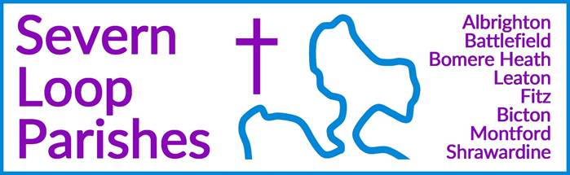

|  |  |  |
| --- | --- | --- |
| **Priest in Charge:** | Revd Hannah Lins | [revhannahlins@gmail.com](mailto:revhannahlins@gmail.com), 07736 012011 |
| **Assistant Priest:** | Revd Peter Allan | [pallan412@gmail.com](mailto:pallan412@gmail.com), 01939 290048 |
| **Pastoral Minister:** | Mrs Joyce Jagger | [pearhill1@outlook.com](mailto:pearhill1@outlook.com), 07802 695954 |
| **Safeguarding Officer:** | Mrs Philippa Herbert | 07871 865253 |
| **Administrator:** | Miss Rosie Dixon | [severn.loopparishes@gmail.com](mailto:severn.loopparishes@gmail.com) |
| **Daily Hope (the national phoneline service)** | | 0800 8048044 |
| *Weekly Collects, readings and reflections are on the website-* [*www.severnloopparishes.org.uk*](http://www.severnloopparishes.org.uk) | | Dementia Action Week at Somerset Museums – South West Heritage Trust |

**JULY LOOP 2025**

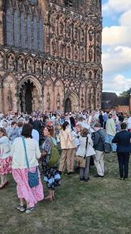**All aboard for Lichfield!**

On Saturday around fifteen of us went to Lichfield, for Dave’s ordination. It was a wonderful service, and we’re so grateful to our two drivers- Caroline Watson and Peter Coxhead- who bundled us up and got us there. Thanks too to all who came along to our welcome service and lunch at Fitz, and particularly to those of you who brought food- it was a feast!

We continue to pray for Dave as he begins his ministry amongst us. His rest day will generally be Saturday, and he will be taking some time off in the summer holidays. His contact details are:

Phone- 07745 968298

Email- [rev.latcham@gmail.com](mailto:rev.latcham@gmail.com)

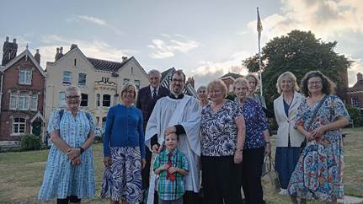

**Forest Church**

Our next Forest Church will be on 13th of July, 3pm, in Bicton Churchyard. Local expert Sue Dancey will be joining us to explore the plants and wildlife, and we will also be planting some community herbs. And if that weren’t enough, Rosie (our Loop Administrator- who is also a dance teacher) will be teaching us how to dance round a maypole… what could possibly go wrong?! The venue will be confirmed nearer the time. Refreshments will be provided, but do bring a packed tea if you’d like to.

**Lychgate Grand Opening**

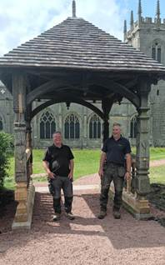

Over at Battlefield the restoration of the lychgate is now complete. Traditionally, lychgates mark the boundary between consecrated and un-consecrated ground, and people walk under them for life’s big moments- baptisms, marriages and funerals. Tony and Gary (pictured right) carried out the restoration, and it looks amazing!

**All are warmly invited to:**

**A service of thanksgiving and blessing to celebrate the opening of the restored Lychgate**

**The Church of St Mary Magdalene, Battlefield**

**Sunday, 20th July 2025, 2pm**

Upon arrival, please gather at the Lychgate. Our service will be followed by a drinks reception. There is a small carpark by the church, or the option of walking across from 1403. We are deeply grateful to *Treasure and Son*, who have carried out this specialist work, and to the *Battlefield Energy Recovery Facility Conservation Management Plan Steering Group* for agreeing to the funding of this project. RSVP to [revhannahlins@gmail.com](mailto:revhannahlins@gmail.com) .

**Loop Prayer and Praise**

Join us for an hour of prayer and informal worship on Wednesday, 23rd July, 7pm-8pm in the Mission Church in Bomere Heath. All welcome.

**Diary Dates**

**CAMEO Coffee Morning at Bicton Church-** 10th July, 10.30am-11.30am.

**The Stepping Out Café in Bomere Heath-** 30th July, 2.30pm-4pm

**Filling Station**- Knockin Village Hall is on 15th July, 7.10pm for a 7.30pm start. The next one at Rodington Village Hall (SY4 4QS) is on 28th July 2025, 7.15pm for a 7.30pm start.

**REVS-** Saturday, 19th July, 10am-noon, Holy Trinity, Leaton.

*Bicton Church is open on Saturday mornings, and Shrawardine Church is open on Saturdays and Sundays.*

**For Your Prayers**

* For our local schools, in these final weeks of term.
* For our local farmers.
* For peace.
* For the recently bereaved, especially the family and friends of Geoffrey Hampson.
* For Forest Church and our ministry to children.
* For those in hospital, and for our NHS.
* For those preparing for Baptism.

**Readings for July**

|  |  |  |  |
| --- | --- | --- | --- |
| **Date** | **Psalm** | **First Reading** | **Second Reading/ Gospel** |
| 6th July  Trinity 3, green | Psalm 66. 1-8 | Galatians 6. 1-16 | Luke 10. 1-11, 16-20 |
| 13th July  Trinity 4, green | Psalm 25. 1-10 | Colossians 1. 1-14 | Luke 10. 25-37 |
| 20th July  Trinity 5, green | Psalm 15 | Colossians 1. 15-28 | Luke 10. 38-end |
| 27th July  Trinity 6, green | Psalm 138 | Colossians 2. 6-15 | Luke 11. 1-13 |
| 3rd August  Trinity 7, green | Psalm 49. 1-12 | Acts 3. 1-11 | Luke 12. 13-21 |

**SUNDAY SERVICES FOR JULY 2025**

|  |  |  |  |  |  |  |  |
| --- | --- | --- | --- | --- | --- | --- | --- |
|  | **Albrighton** | **Bicton** | **Bomere**  **Heath** | **Fitz** | **Leaton** | **Montford** | **Shrawardine** |
| **6th July** | 9.15 am  HC | 11 am  HC |  | 9.30 am  MP | 10.45 am  HC  Baptism 12.30pm |  | 9.30 am  MP |
| **13th July** |  | 11 am  MP | 9 am  HC |  | 10.45 am  MP | 9.30 am  HC | 11 am  HC |
| **20th July** | 9.15 am  MP | 11 am  HC |  | 9.30 am  HC | 10.45 am  HC | 9.30 am  MP |  |
| **27th July** |  | 11 am  MP | 9 am  HC |  | 10.45 am  MP | 11 am  HC | 9.30 am  HC |
| **3rd August** | 9.15 am  HC | 11 am  HC |  | NO SERVICE | 10.45 am  HC |  | 9.30 am  MP |

***HC- Holy Communion; MP- Morning Prayer***

**OTHER WAYS TO WORSHIP ON SUNDAYS-** SUNDAY AT SIX 6 pm via Zoom – email Peter or Hannah to receive the link.DAILY HOPE – national phone line, see number above.LICHFIELD CATHEDRAL- www.lichfield-cathedral.org 10.30 am Eucharist

