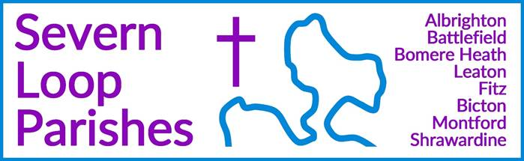
Priest in Charge: | Revd Hannah Lins | revhannahlins@gmail.com, 07736 012011
Assistant Priest:  Curate: | Revd Peter Allan  Revd David Latcham | pallan412@gmail.com, 01939 290048  rev.latcham@gmail.com, 07745 968298
Pastoral Minister: | Mrs Joyce Jagger | pearhill1@outlook.com, 07802 695954
Safeguarding Officer: | Mrs Philippa Herbert | 07871 865253
Administrator: | Miss Rosie Dixon | severn.loopparishes@gmail.com
Daily Hope (the national phoneline service) |  | 0800 8048044
Weekly Collects, readings and reflections are on the website- www.severnloopparishes.org.uk |  | 
NOVEMBER LOOP 2025
Remembering our pets
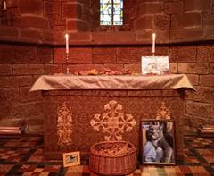
Last Sunday a number of us gathered at Albrighton for a service to remember our non-human companions who we have loved and lost. It was a very special time, and a privilege to provide a space for people to grieve this very particular kind of loss, which often struggles to find a home in our culture. We heard some words from The Horse and His Boy (CS Lewis) about the comfort of a cat, who was really Aslan, and we reflected on the blessing our pets bring us. We then had a time of remembering, when people were invited to bring autumn leaves to the altar, along with any photos they had with them. Our service was followed by refreshments, and we are very grateful to the team at Albrighton for making everyone so welcome. We will do this again next year!

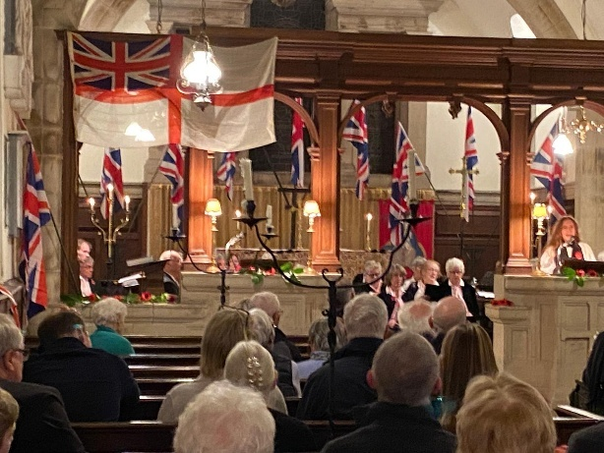
Remembrance
Remembrance Sunday falls on 9th November this year. As always, we have morning services that include an act of remembrance at Bomere (9am), Montford (9.30am), Leaton (10.45am), Bicton (10.50am) and Shrawardine (10.50am). Please note the earlier start time for Bicton and Shrawardine. All are warmly invited to our Festival of Remembrance with the Yeoman Singers at Fitz, 5.30pm. As always, we are deeply grateful to Peter Malpass for putting this very special event together.


Forest Church
Our next Forest Church will be on Sunday 23rd November at Bomere Mission Church, 3pm. Join us for indoor festive woodland crafts, ending with a short worship service and cake. All welcome!

St. PETER & St. PAUL’S CHURCH
FITZ

COMMUNITY ADVENT LUNCH
With Festive Singalong
FITZ VILLAGE HALL
SUNDAY 30th NOVEMBER
12:30pm
ADULTS £10—CHILDREN £5
Tickets Available from Avril
On 01743 850262. avril.stephens10@gmail.com
Please Bring Your Own Drink

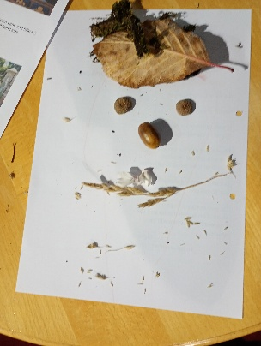
Loop Explorers update
Loop Explorers is our new after school group for primary aged children that meets fortnightly on a Thursday in Bicton church. Each session we explore something about ourselves, God, God's world and God's word - which for our first session meant a combination of nature self-portraits, drawing a Psalm on big bits of paper, and hot chocolate! Primary-aged children are welcome- but do book a place by contacting revhannahlins@gmail.com.

Bomere Small Group update
There is something about meeting as a small group of people to study the Bible that allows you to dig deeper into what God's word says, and explore more personally than might happen otherwise. Our new fortnightly small group meets on Wednesday evenings in Bomere Mission Church, and we are currently going through the book of Romans and finding out what it has to tell us about Jesus and our lives with him. All welcome!

Diary Dates
CAMEO Coffee Morning at Bicton Church- 13th November, 10.30am-11.30am.
The Stepping Out Café in Bomere Heath- 26th November, 2.30pm-4pm
Coffee Morning at Shrawardine- 18th November, at the home of Esther Oates (The Old Dairy)
Filling Station- Knockin Village Hall is on 18th November, 7.10pm for a 7.30pm start (Hannah is the speaker). The next one at Rodington Village Hall (SY4 4QS) is on 24th November 2025, 7.15pm for a 7.30pm start.
REVS- Saturday, 15th November, 10am-noon, Holy Trinity, Leaton.

For Your Prayers
- For those who find the season of remembrance particularly poignant.
- For peace.
- For the recently bereaved, especially those coming along to our Remembering with Love service.
- For Forest Church and our ministry to children and young people, particularly Loop Explorers, which began in October, and the new lunchtime club at Corbet School.
- For those in hospital, and for our NHS.
- For those sleeping on the streets as the nights are so cold.
- For Filling Station- Hannah is the speaker in November!

Light for a Loved One

As last year, Bicton Church is inviting members of the community to remember loved ones over the Christmas period on the notice board outside church, and on our Christmas Tree. If you would like to be part of this, contact Clare Dixon or Rosie Dixon (severn.loopparishes@gmail.com).

Readings for November
Date | Psalm | First Reading | Second Reading/ Gospel
2nd November  All Saints, white | Psalm 149 | Ephesians 1. 11-23 | Luke 6. 20-31
9th November  Remembrance, red | Psalm 17. 1-9 | 2 Thessalonians 2. 1-5, 13-17 | Luke 20. 27-38
16th November  2 before Advent, green | Psalm 98 | 2 Thessalonians 3. 6-13 | Luke 21. 5-19
23rd November  Christ the King, red | Psalm 46 | Colossians 1. 11-20 | Luke 23. 33-43
30th November  Advent 1, purple | Psalm 122 | Romans 13. 11-14 | Matthew 24. 36-44
7th December  Advent 2, purple | Psalm 72. 1-7, 18, 19 | Romans 15. 4-13 | Matthew 3. 1-12

SUNDAY SERVICES FOR NOVEMBER 2025
 | Albrighton | Bicton | Bomere  Heath | Fitz | Leaton | Montford | Shrawardine
2nd November | 9.15 am  HC | 11 am  HC |  | 9.30 am  MP | 10.45 am  HC  3pm  Remembering with love |  | 9.30 am  MP
9th November |  | 10.50am  MP | 9 am  HC | 5.30pm  Festival of Remembrance | 10.45 am  MP | 9.30 am  HC | 10.50 am  HC
16th November | 9.15 am  MP | 11 am  HC |  | 9.30 am  HC | 10.45 am  HC | 9.30 am  MP
23rd November |  | 11 am  MP | 9 am  HC  3pm  Forest Church |  | 10.45 am  MP | 11 am  HC | 9.30 am  HC
30th November |  | United Service 10.30am |  | Advent Lunch with Christmas singalong
7th December | 9.15 am  HC  2pm Preston Gubbals Carol Service | 11 am  HC |  | 9.30 am  MP | 10.45 am  HC  6pm  REVS Carols by Carlight |  | 9.30 am  MP

HC- Holy Communion; MP- Morning Prayer

OTHER WAYS TO WORSHIP ON SUNDAYS- SUNDAY AT SIX 6 pm via Zoom – email Peter or Hannah to receive the link. DAILY HOPE – national phone line, see number above. LICHFIELD CATHEDRAL- www.lichfield-cathedral.org 10.30 am Eucharist

