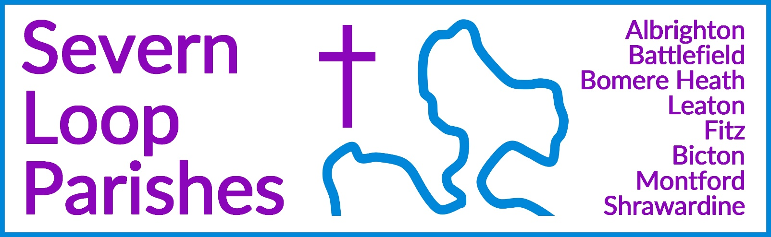
Priest in Charge: | Revd Hannah Lins | revhannahlins@gmail.com, 07736 012011
Assistant Priest:  Curate: | Revd Peter Allan  Revd David Latcham | pallan412@gmail.com, 01939 290048  rev.latcham@gmail.com, 07745 968298
Pastoral Minister: | Mrs Joyce Jagger | pearhill1@outlook.com, 07802 695954
Safeguarding Officer: | Mrs Philippa Herbert | 07871 865253
Administrator: | Miss Rosie Dixon | severn.loopparishes@gmail.com
Daily Hope (the national phoneline service) |  | 0800 8048044
Weekly Collects, readings and reflections are on the website- www.severnloopparishes.org.uk |  | 
DECEMBER LOOP 2025
Can we find traces of the Gospel on the telly?!
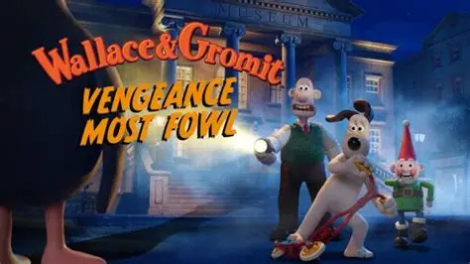
One of the most popular programmes on TV last Christmas was the latest Wallace and Gromit film- Vengeance most Fowl.

Behind the cute and creative style, there are some deep messages about good and evil, home and alienation, love, friendship, distraction and the limits of technology! And because it was so widely watched, we know too that it has meaning for our culture- not just in the charm of stop-go animation, but also in the substance of the story. How do some of those themes help us to understand the love of God in Christ? What resonances might they have with the Gospel message?

On Tuesday mornings during advent, we are going to explore these very questions. We will begin with a short service of Holy Communion, and then (with a cup of coffee in our hands) we will watch a section of the film and discuss its message. We will be joined by our methodist friends, and all are welcome!

10.45am- noon, The Mission Church in Bomere Heath, Tuesdays 2nd, 9th, 16th December.
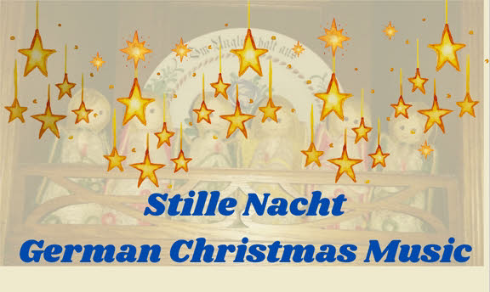
Christmas Carol Services

Carol Services around Severn Loop:
Battlefield- 20th December, 11am
Bicton- 14th December, 5pm
Albrighton Morning Prayer with Carols- 21st December, 9.15am
Montford- 14th December, 11am
Leaton- 14th December, 7pm
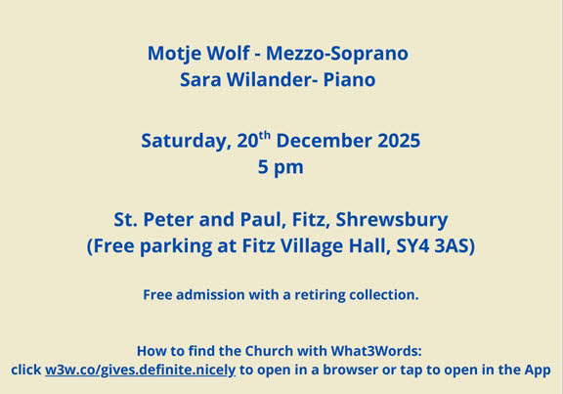
Preston Gubbals- 7th December, 2pm
Fitz- 21st December, 5pm followed by refreshments at
The Old Rectory (by kind invitation of the Leach family)
Shrawardine- 21st December, 7pm

Carol singing in the Red Lion pub in Bomere Heath will be on 19th December, 6pm.
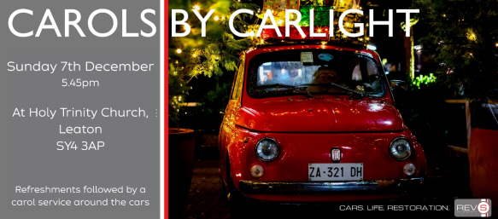

Fancy a Loopy Sunday Afternoon?
In the new year, we aim to start an informal, Sunday afternoon worship time, meeting at 3pm on the 2nd Sunday each month at Bomere Mission Church. Our plans are still coming together, but we want something that is open for those who might find an afternoon session with interactive stories and activities helpful. If this interests you, and you would like to hear more going forwards, drop Dave an email - rev.latcham@gmail.com

Montford and Shrawardine Pantomime
Montford Parish Hall Management Committee with Montford and Shrawardine Social Committee present The Severn Loop Players in:
ALICE IN WONDERLAND
written by Michele Lee
Friday 16th January 2026 at 7.30 p.m. Saturday 17th 2.30 p.m. and 7.30 p.m.
Tickets: Adults £9. School age children 16 and under £4.50 (includes light refreshments)
Available from Tricia 01743 850810 or 07780 523615


Prayer Shawl Ministry- a message from Joyce

Definition : Prayer shawl ministry combines the art of knitting or crocheting with prayer to create shawls that provide comfort and love. They are a tangible expression of care and support. Each stitch is infused with love and intention making the shawl a form of prayer”.

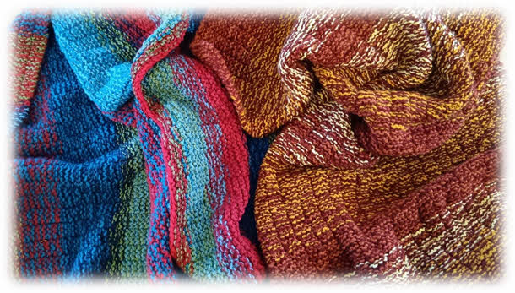
This slightly formal definition does not do justice to the deep joy and emotional response that is displayed by those receiving a prayer shawl. The shawls are often, although not always, given to individuals during difficult times; those who have the gift of creativity give something special to a person who might be struggling. It is a physical reminder of the love and prayers surrounding them and a reminder that they are not forgotten or alone. They are not forgotten by us and they are not forgotten by God. The prayer shawls are accompanied with a personal prayer when being delivered. A shawl always seems to arrive just when one is needed so thankyou to the knitters in the Loop. Patterns can be found on the website (and I have been asked this, so yes, you can watch tv while knitting!). If you have kindly created a prayer shawl please give to Hannah, Peter, Dave or Joyce and we will ensure that it gets to the right place. This is always confidential.

Sunday@6
Please note, there will be NO Sunday@6 on the 7th and 21st December- we are all hands to the deck for our carol services!

Save the Date
Bicton Church are hosting a talk with refreshments on the afternoon of Saturday, 17th January 2026. It’s called ‘The Biscuit Club’ and is a fascinating insight into the frontline nursing in Afghanistan. More information next month.

Diary Dates
CAMEO Coffee Morning at Bicton Church- 11th December, 10.30am-11.30am.
The Stepping Out Café in Bomere Heath- None in December.
Filling Station- There is no Filling Station in December.
REVS- None in December- but there is a Carols by Carlight service, 7th December, 5.45pm.

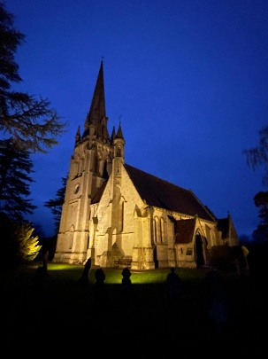
Thank you

An enormous thank you to all of you involved in making our Christmas services happen- to churchwardens, organists, welcomers, cleaners, decorators, readers. Christmas is a very special time in the Loop, and we hope and pray that those who come to our churches will experience the love of God-with-us- Emmanuel.

For Your Prayers
- For our local farmers.
- For peace in the Middle East and Ukraine.
- For our local schools as we welcome them into church at Christmas time.
- For our new lunch club at Corbet School, exploring the questions of faith.
- For all who will come to our Christmas services and events.
- For the children in the choir and handbell club at Bicton, as they visit nursing homes in the area.
- For those in hospital, and for our NHS.
- For those sleeping on the streets as the nights get cooler.
- For the recently bereaved- particularly the family and friends of Maurice Hoare, Jim Anderson, Peggy Ward, John Kaye and John Pugh.

Readings for December

Date | Psalm | First Reading | Second/ Gospel Reading
7th December  Advent 2 | 72.  1-7, 18, 19 | Romans 15. 4-13 | Matthew 3. 1-12
14th December  Advent 3 | 146. 4-10 | James 5. 7-10 | Matthew 11. 2-11
21st December  Advent 4 | 80.  1-8, 18-20 | Romans 1. 1-7 | Matthew 1. 18-25
Christmas Night/ Christmas Day |  | Isaiah 9.2-7 | Luke 2. 1-20
28th December  Holy Innocents | 124 | 1 Corinthians 1.  26-29 | Matthew 2. 13-18
4th January | 72. [1-9]  10-15 | Ephesians 3. 1-12 | Matthew 2. 1-12

Please note that on 28th December, there will only be one service in Severn Loop- a united service at the Leaton Church, 10.30am.

See next page for service details….

SUNDAY SERVICES FOR DECEMBER 2025

 | Albrighton | Bicton | Bomere  Heath | Fitz | Leaton | Montford | Shrawardine
7th December  purple | 9.15 am  HC  2pm Preston Gubbals Carol Service | 11 am  HC |  | 9.30 am  MP | 10.45 am  HC |  | 9.30 am  MP
14th December  purple |  | 5pm Carol Service | 9 am  HC |  | 7pm Carol Service | 11am Carol Service
20th  December | 11am Battlefield Carol Service
21st December  Purple | 9.15 am  MP with Carols | 11am  HC |  | 9.30 am  HC  5pm Carol Service | 10.45am  HC | 9.30am  MP | 7pm Carol Service
24th December  Christmas Eve  White |  | 4pm Crib Service  9pm Christmas Communion |  |  | 4pm  Crib Service  11.30pm  Christmas Communion | 5.30pm Family Christmas Communion and Carols
25th December  Christmas Day  White | 9.30am  Christmas Communion |  | 10.30am  Christmas Communion | 10.30am  Christmas Communion |  |  | 9am  Christmas Communion
28th December  White |  |  |  |  | 10.30am  United Service

HC- Holy Communion; MP- Morning Prayer

OTHER WAYS TO WORSHIP ON SUNDAYS- SUNDAY AT SIX 6 pm via Zoom – email Peter or Hannah to receive the link. SHARING THE LIGHT IN THE LOOP- weekly phone line worship – see top of this page for the number. DAILY HOPE – national phone line, see number above. LICHFIELD CATHEDRAL- www.lichfield-cathedral.org 10.30 am Eucharist

