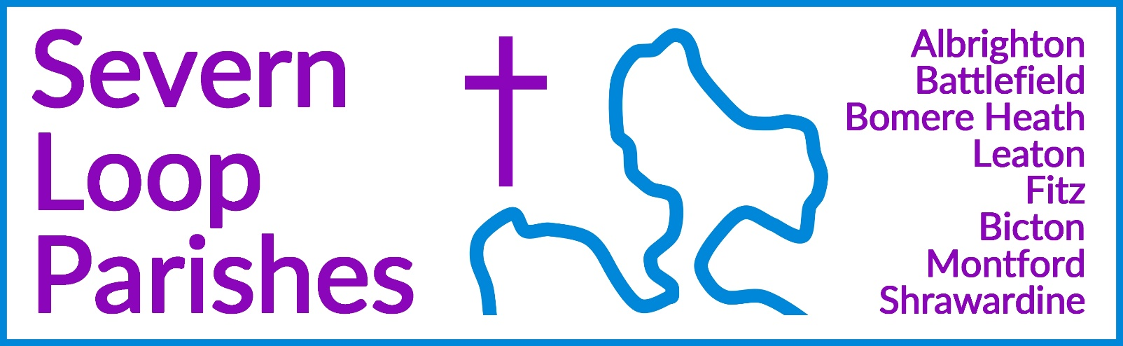
Priest in Charge: | Revd Hannah Lins | revhannahlins@gmail.com, 07736 012011
Assistant Priest:  Curate: | Revd Peter Allan  Revd David Latcham | pallan412@gmail.com, 01939 290048  rev.latcham@gmail.com, 07745 968298
Pastoral Minister: | Mrs Joyce Jagger | pearhill1@outlook.com, 07802 695954
Safeguarding Officer: | Mrs Philippa Herbert | 07871 865253
Administrator: | Miss Rosie Dixon | severn.loopparishes@gmail.com
Daily Hope (the national phoneline service) |  | 0800 8048044
Weekly Collects, readings and reflections are on the website- www.severnloopparishes.org.uk |  | 
JANUARY LOOP 2026
Happy New Year to you all… and thank you!

On behalf of the staff team, thank you all so much for the wonderful cards, presents and good wishes we received over the festive season- you are so kind! Thank you too for all that you did to contribute to the life of our churches- for decorating, reading lessons, preparing refreshments, cleaning, playing the organ, recruiting help, swinging a handbell… the list goes on. We are SO grateful to be part of such a special group of communities, and our continued prayer is that those who came along to our Christmas services and events (nearing 500 people in total) will know the peace and love of the Christ-child in their daily lives.
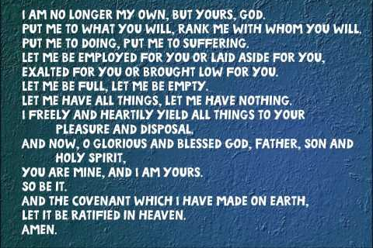
We are acutely aware that for many of you, 2025 was a difficult and challenging year. We know too that there is a lot of illness around just at the moment. As 2026 dawns, we pray for joy, peace, health and hope. Here is the Methodist Covenant prayer for you to use at home- dragged out every year to terrify us!

A Happy New Year from us all xxx
Loopy Sundays

Our new, informal Sunday afternoon worship begins this month. We are meeting at 3pm on the 11th January at the Mission Church in Bomere Heath. Do join us for an afternoon of interactive Bible stories and activities, singing and snacking, suitable for all ages. This month, the theme is the Baptism of Jesus- so it might get a bit wet! Feel free to just turn up, but if you’d like to find out more in advance, do email Dave - rev.latcham@gmail.com .

The Biscuit Club
Bicton Church are hosting an afternoon talk about nursing in Afghanistan, called ‘The Biscuit Club’. Tickets are £10 to include refreshments, and do contact Wendy Horan (01743 850237) or Clare Dixon (01743 361906) to book.

Saturday, 17th January 2026
Bicton Village Hall, 2pm

Proceeds in aid of Church Funds

Montford and Shrawardine Pantomime
Montford Parish Hall Management Committee with Montford and Shrawardine Social Committee present The Severn Loop Players in:
ALICE IN WONDERLAND
written by Michele Lee
Friday 16th January 2026 at 7.30 p.m. Saturday 17th 2.30 p.m. and 7.30 p.m.
Tickets: Adults £9. School age children 16 and under £4.50 (includes light refreshments)
Available from Tricia 01743 850810 or 07780 523615

Burn’s Night Supper and Ceilidh

with CuckCuriosity - Ray and Bev Langton

Saturday 31st January, 2026

at Montford Parish Hall, 7 p.m.

Traditional three course supper and coffee.
Please bring your own drinks, glasses provided.

Tickets £22.50 – Limited to 80 – (tables of 8), so there is room to dance.
Available from Tricia on 07780 523615 or Esther on 07484777625

Loop Prayer and Praise
Our termly hour of prayer and informal sung worship will be on Wednesday, 7th January, 7pm-8pm in the Mission Church in Bomere Heath (it’ll be followed by home group at 8pm). Do join us as we pray particularly for our new ministries- Loop Sundays, Loop Explorers and Loop Life (our children and youth groups) and the lunch club at Corbet School.

Candlemas
This year our united service for Candlemas will be at Shrawardine, 10.30am, on Sunday, 1st February. As ever, we are hoping for a scratch choir to materialise! If you’d like to be part of it, we will meet at 9.15am at the church to practice.

Diary Dates
CAMEO Coffee Morning at Bicton Church- 8th February, 10.30am-11.30am.
The Stepping Out Café in Bomere Heath- 28th January, 2.30pm-4pm
Filling Station- 20th January, 7pm for 7.30pm, Knockin Village Hall
REVS- 17th January, 10am-noon, Leaton Church

For Your Prayers
- For our local farmers.
- For peace in Sudan, the Middle East and Ukraine.
- For our local schools as term begins again.
- For our new lunch club at Corbet School, exploring the questions of faith.
- For those in hospital, and for our NHS.
- For those sleeping on the streets as snow threatens.
- For the recently bereaved- particularly the family and friends of Mary Cunningham, Geoff Hall and Michael Jackson.

Readings for January
DAY | PSALM | 1ST READING | 2nd READING/ GOSPEL
4th January  Epiphany | Psalm 72. [1-9] 10-15 | Ephesians 3. 1-12 | Matthew 2. 1-12
11th January  Baptism of Christ | Psalm 29 | Acts 10. 34-43 | Matthew 3. 13-17
18th January  Second Sunday of Epiphany | Psalm 40. 1-12 | 1 Corinthians 1.1-9 | John 1. 29-42
25th January  Third Sunday of Epiphany | Psalm 27. 1,4-12 | 1 Corinthians 1. 10-18 | Matthew 4. 12-23
1st February  Candlemas | Psalm 24. [1-6] 7-10 | Hebrews 2. 14-18 | Luke 2. 22-40
See next page for service details….

SUNDAY SERVICES FOR JANUARY

 | Albrighton | Bicton | Bomere  Heath | Fitz | Leaton | Montford | Shrawardine
4th January  Epiphany | 9.15 am  HC | 11 am  MP |  | 9.30 am  MP | 10.45 am  HC |  | 9.30 am  MP
11th January  Baptism of Christ |  | 11 am  HC | 9 am  HC  3pm Loopy Sunday |  | 10.45 am  MP | 9.30 am  HC | 11 am  HC
18th January  Epiphany 2 | 9.15 am  MP | 11 am  HC |  | 9.30 am  HC | 10.45 am  HC | 9.30 am  MP
25th January  Epiphany 3 |  | 11 am  MP | 9 am  HC |  | 10.45 am  MP | 11 am  HC | 9.30 am  HC
1st February  Candlemas |  |  |  |  |  |  | 10.30am  United Service

HC- Holy Communion; MP- Morning Prayer

OTHER WAYS TO WORSHIP ON SUNDAYS- SUNDAY AT SIX 6 pm via Zoom – email Peter or Hannah to receive the link. SHARING THE LIGHT IN THE LOOP- weekly phone line worship – see top of this page for the number. DAILY HOPE – national phone line, see number above. LICHFIELD CATHEDRAL- www.lichfield-cathedral.org 10.30 am Eucharist

