
COLLECT, READINGS AND REFLECTION
SUNDAY 15 FEBRUARY 2026 – Sunday before Lent

COLLECT
Almighty Father,
whose Son was revealed in majesty
before he suffered death upon the cross:
give us grace to perceive his glory,
that we may be strengthened to suffer with him
and be changed into his likeness, from glory to glory;
who is alive and reigns with you,
in the unity of the Holy Spirit,
one God, now and for ever.

Psalm 99
1 The Lord is king: let the peoples tremble; ♦
he is enthroned above the cherubim: let the earth shake.
2 The Lord is great in Zion ♦
and high above all peoples.
3 Let them praise your name, which is great and awesome; ♦
the Lord our God is holy.
4 Mighty king, who loves justice,
you have established equity; ♦
you have executed justice and righteousness in Jacob.
5 Exalt the Lord our God; ♦
bow down before his footstool, for he is holy.
6 Moses and Aaron among his priests
and Samuel among those who call upon his name; ♦
they called upon the Lord and he answered them.
7 He spoke to them out of the pillar of cloud; ♦
they kept his testimonies and the law that he gave them.
8 You answered them, O Lord our God; ♦
you were a God who forgave them
and pardoned them for their offences.
9 Exalt the Lord our God
and worship him upon his holy hill, ♦
for the Lord our God is holy.

A reading from the second epistle of Peter, chapter 1, verses 16-21.

For we did not follow cleverly devised myths when we made known to you the power and coming of our Lord Jesus Christ, but we had been eyewitnesses of his majesty. For he received honour and glory from God the Father when that voice was conveyed to him by the Majestic Glory, saying, ‘This is my Son, my Beloved, with whom I am well pleased.’ We ourselves heard this voice come from heaven, while we were with him on the holy mountain.
So we have the prophetic message more fully confirmed. You will do well to be attentive to this as to a lamp shining in a dark place, until the day dawns and the morning star rises in your hearts. First of all you must understand this, that no prophecy of scripture is a matter of one’s own interpretation, because no prophecy ever came by human will, but men and women moved by the Holy Spirit spoke from God.

This is the word of the Lord.
Thanks be to God.
At Morning Prayer, the Gospel is simply the second reading, people sit to hear it and is introduced in the same way as the first:
The second reading is Matthew, chapter 17, verses 1-9.
and then at the end:
For the word of the Lord
Thanks be to God.

For Eucharists/ Communion people stand to hear the Gospel.

Allelluia,

Allelluia.

I am the light of the world, says the Lord,

whoever follows me will have the light of life.

Alleluia

Hear the Gospel of our Lord Jesus Christ according to Matthew, Chapter 17, verses 1-9.
Glory to you, O Lord.
Then at the end:
This is the Gospel of the Lord.
Praise to you, O Christ.
Six days later, Jesus took with him Peter and James and his brother John and led them up a high mountain, by themselves. And he was transfigured before them, and his face shone like the sun, and his clothes became dazzling white. Suddenly there appeared to them Moses and Elijah, talking with him. Then Peter said to Jesus, ‘Lord, it is good for us to be here; if you wish, I will make three dwellings here, one for you, one for Moses, and one for Elijah.’ While he was still speaking, suddenly a bright cloud overshadowed them, and from the cloud a voice said, ‘This is my Son, the Beloved; with him I am well pleased; listen to him!’ When the disciples heard this, they fell to the ground and were overcome by fear. But Jesus came and touched them, saying, ‘Get up and do not be afraid.’ And when they looked up, they saw no one except Jesus himself alone.
As they were coming down the mountain, Jesus ordered them, ‘Tell no one about the vision until after the Son of Man has been raised from the dead.’

A Reflection from Hannah
Some years ago, a piece of graffiti art by Banksy appeared in Margate. It included a real fridge, leant up against a wall- without the fridge, the image didn’t make sense. Within a couple of hours, the fridge had been removed by the council. The irony was that people had been complaining to that same council about fly-tipping for months, and they had not come and removed the many other fridges (and similar discarded objects) that were not part of an art installation. It was a lamentable (if comical) misreading of the situation!
Sometimes we do the wrong thing, at the wrong time, and we do it with finesse and flourish! A similar thing is going on in our reading today when, amidst the breath-taking glory of the transfiguration, Peter decides to suggest that it might be good to put up some tents- to contain Jesus, Moses and Elijah. And yet this obvious faux-pas doesn’t make a jot of difference- God speaks, the people fall down in response, and the unfolding splendour, awe, majesty Christ transfigured continues, uninterrupted.
It's a reassurance to know that however much we might put our foot in it, God will not be thwarted. More than that, we are still included- Peter, in spite of his daft suggestion, nevertheless experienced the fullness of this moment, and its memory would sustain him in the years to come.
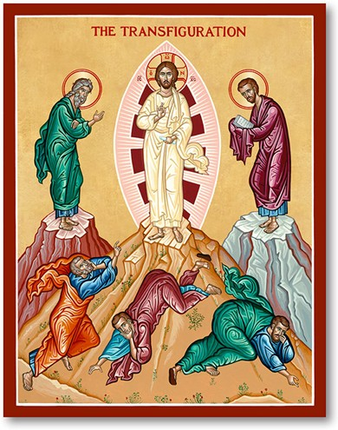
And then after the moment, when the dazzling shrinks back to normality- and they once again behold a simple human, fellow man- those familiar words are spoken again ‘do not be afraid’. Last week in our Gospel reading, Christ says ‘do not worry’- the disciples seem to need to hear that kind of reassurance many times over. Perhaps we do too…
But that’s ok- as we know, there is plenty to worry about and lots to lament, but there is a hope that is bigger than our fear. There is a hope that just occasionally gifts us a moment where we can see things differently, gloriously- as in the transfiguration- and that experience gives us strength that we can draw on in the other times- the times when we do feel at the end of ourselves. Indeed, it is precisely because of that, that the transfiguration is the first painting an Icon Painter learns to paint.
So perhaps you can think of a ‘transfiguration moment’- one of those times, like the one described here, when the ordinary quite unexpectedly became infused with the transcendent presence of God-who-is-love, and it changed everything.

