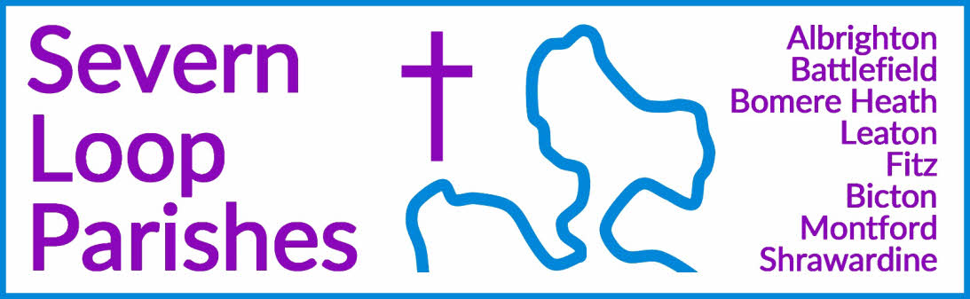
Priest in Charge: | Revd Hannah Lins | revhannahlins@gmail.com, 07736 012011
Assistant Priest:  Curate: | Revd Peter Allan  Revd David Latcham | pallan412@gmail.com, 01939 290048  rev.latcham@gmail.com, 07745 968298
Pastoral Minister: | Mrs Joyce Jagger | pearhill1@outlook.com, 07802 695954
Safeguarding Officer: | Mrs Philippa Herbert | 07871 865253
Administrator: | Miss Rosie Dixon | severn.loopparishes@gmail.com
Daily Hope (the national phoneline service) |  | 0800 8048044
Weekly Collects, readings and reflections are on the website- www.severnloopparishes.org.uk |  | 
MARCH LOOP 2026
The journey continues…
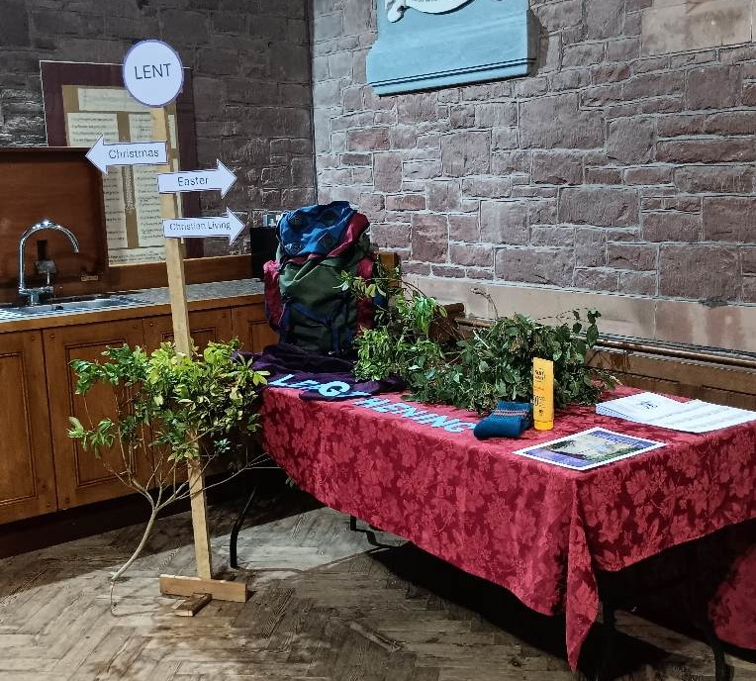
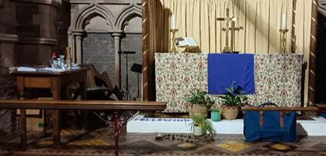
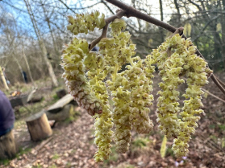
Ironically, Lent has been busy! Last Sunday we had a small, but ‘wild’ Forest Church around a fire in the Forest School area at Bicton School, and it was lovely to gather and enjoy nature together. We’ve also run the Lent Experience for both of our primary schools- where the children have been invited to consider what it means to follow Jesus, to let go of things that diminish us, to make good decisions and grow into the people God has created us to be. It was an absolute delight to spend time reflecting together on how we can learn from Jesus’ time in the wilderness and how the Holy Spirit nourishes us as pilgrims together today.

Looking forward to Holy Week and Easter:
29th March- Palm/ Passion Sunday- a united service at Montford (10.30am), followed by Forest Church at Huffley (3pm)
2nd April- Maundy Thursday- 7pm Eucharist at Bicton/ 7pm Agape meal at Bomere Mission Church
3rd April- Good Friday- 2pm Last hour at Bicton/ 2pm Last hour at Bomere Mission Church
5th April- Easter Day (deep breath!):
5.30am- Battlefield
8am- Shrawardine
8am- Bomere Heath
9am- Montford
9.15am- Albrighton
10.15am- Fitz
10.45am- Leaton
11.15am- Bicton


Loopy Sundays
Our new, informal Sunday afternoon worship is continuing into March! We are meeting at 3pm on the 8th March at the Mission Church in Bomere Heath. Do join us for an afternoon of interactive Bible stories and activities, singing and snacking, suitable for all ages- this month the story is the woman at the well (John 4). This month, we will be exploring the idea of lent (which began in Feb) and forgiveness through Jesus' parable of the lost son. Feel free to just turn up, but if you’d like to find out more in advance, do email Dave - rev.latcham@gmail.com.

Wednesday eve Small Group in Lent - reading Mark's gospel
During Lent, the Wednesday night Small Group will be reading through the whole of Mark's gospel in 3 parts, as a powerful way to see how Jesus' whole life and ministry lead towards Easter.
Join us on March 4th and 18th, and April 1st (in Holy Week) at 7:30pm in the Mission Church, Bomere Heath. For more details contact Dave - rev.latcham@gmail.com.


Forest Church
29th March at Huffley, 3pm
We hope to see the newborn lambs and there will be Easter crafts!

Of One Accord Concert- 5th June, Bicton Church
A wonderful evening of uplifting music with Of One Accord, a mixed voice choir nestled in Shrewsbury. Tickets: £10 Including refreshments
To book your tickets, please contact Wendy/Clare – 01743 850237/01743 361906 or e-mail severn.loopparishes@gmail.com


Boardgames and Puzzles at the Mission Church
If you are looking for a fun afternoon during the Easter holidays, then join us for Boardgames and Puzzles on Mon 30th March, 2-4:30pm, at the Mission Church in Bomere. There will be a selection of board games and puzzles for all ages and abilities, as well as refreshments. Do drop in, and for more information contact rev.latcham@gmail.com

Paint a Pot Evening
Maybe a gift for Mothering Sunday, a Birthday present or a gift for yourself.

Friday 6th March 7.30pm at Mission Church, Bomere Heath.
Cost £12 to include a pot to paint and materials to paint with.
Please speak to Pat Hall, 01939 290637.

Coffee Mornings at Shrawardine
Come and join us for a friendly chat, coffee and cake!
There will be a sign on the church gate telling you the venue! The next one is on 17th March. for more information contact Jane or Mandy (07730 402037)

Spring Coffee Mornings at Fitz
At Fitz Village Hall, Saturday, 21st March, 10.30am.

Diary Dates
CAMEO Coffee Morning at Bicton Church- 12th March, 10.30am-11.30am.
The Stepping Out Café in Bomere Heath- 25th March, 2.30pm-4pm
Filling Station- 17th March, 7.15pm for 7.30pm, Knockin Assembly Rooms. Free refreshments. This month's speaker will be Harry Warrell, Worship Pastor at Telford Minster. For more info ask Philippa Herbert 07871 865253.
REVS- 21st March, 10am-noon, Leaton Church

For Your Prayers
- For our local farmers.
- For peace in Sudan, the Middle East and Ukraine.
- For our local schools.
- For our new lunch club at Corbet School, exploring the questions of faith.
- For those in hospital, and for our NHS.
- For the recently bereaved- particularly the family and friends of Ann Hammonds, Mary Matthews, Frank Keighley and Angela Littley.
- Claire and Adam, who are getting married at Bicton during Easter week.
Readings for March
DAY | PSALM | 1ST READING | 2nd READING/ GOSPEL
1st March  Second Sunday of Lent | Psalm 121 | Romans 4. 1-5,13-17 | John 3. 1-17
8th March  Third Sunday of Lent | Psalm 95 | Romans 5. 1-11 | John 4. 5-42
15th March  Mothering Sunday | Psalm 127 | Colossians 3. 12-17 | John 19. 25-27
22nd March  Fifth Sunday of Lent | Psalm 130 | Romans 8. 6-11 | John 11. 1-45
29th March
Palm Sunday
2nd April  Maundy Thursday | Psalm 116. 1, 10-17 | 1 Corinthians 11.  23-26 | John 13.  1-17, 31b-35

SUNDAY SERVICES FOR MARCH
 | Albrighton | Bicton | Bomere  Heath | Fitz | Leaton | Montford | Shrawardine
1st March  Lent 2 | 9.15am  HC | 11am  HC |  | 9.30am  HC | 10.45am  HC |  | 9.30am  MP
8th March  Lent 3 |  | 11 am  HC | 9am  HC |  | 10.45 am  MP | 9.30 am  HC | 11 am  HC
15th March  Mothering Sunday | 9.15 am  MP | 11 am  MP |  | 9.30 am  MP | 10.45 am  HC | 9.30 am  MP | 9.30am  MP
22nd March  First Sunday of Lent |  | 11 am  MP | 9 am  HC |  | 10.45 am  MP | 11 am  HC | 9.30 am  HC
29th March  Palm Sunday | 3pm Forest Church at Huffley |  |  |  |  | 10.30am United service
2nd April  Maundy Thursday |  | 7pm Eucharist | 7pm Agape

HC- Holy Communion; MP- Morning Prayer

OTHER WAYS TO WORSHIP ON SUNDAYS- SUNDAY AT SIX 6 pm via Zoom – email Peter or Hannah to receive the link. SHARING THE LIGHT IN THE LOOP- weekly phone line worship – see top of this page for the number. DAILY HOPE – national phone line, see number above. LICHFIELD CATHEDRAL- www.lichfield-cathedral.org 10.30 am Eucharist

