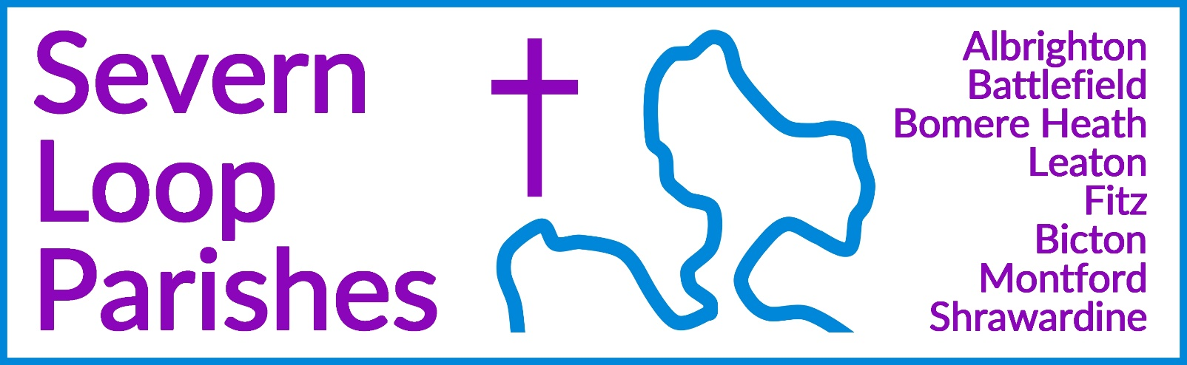
Priest in Charge: | Revd Hannah Lins | revhannahlins@gmail.com, 07736 012011
Assistant Priest:  Curate: | Revd Peter Allan  Revd David Latcham | pallan412@gmail.com, 01939 290048  rev.latcham@gmail.com, 07745 968298
Pastoral Minister: | Mrs Joyce Jagger | pearhill1@outlook.com, 07802 695954
Safeguarding Officer: | Mrs Philippa Herbert | 07871 865253
Administrator: | Miss Rosie Dixon | severn.loopparishes@gmail.com
Daily Hope (the national phoneline service) |  | 0800 8048044
Weekly Collects, readings and reflections are on the website- www.severnloopparishes.org.uk |  | 
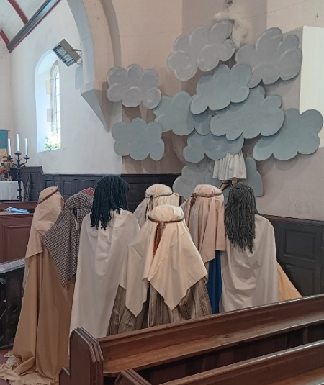
MAY LOOP 2026
The Easter Season continues…
It was wonderful to see so many folk around our church communities as we celebrated Easter- beginning with… wait for it… 22 people at Battlefield at 5am! What a joy. As we continue to journey with Jesus in hope, we will celebrate the Ascension at Battlefield too- 4pm, Thursday, 14th May, followed by refreshments in the sunshine (we hope). Do join us. As a reminder of last year, here is the Station of the Resurrection for the Ascension- at Montford (brilliantly depicted!).

Forest Church
We had a fab time at Forest Church at Preston Montford Field Studies Centre- we were small in number, but the advantage of that was that we all had a go at pond-dipping! Sue Dancey led us through the afternoon, and we all learnt so much. Our next Forest Church will be on The Isle Estate, 28th June 2026, 3pm.
Loopy Sundays
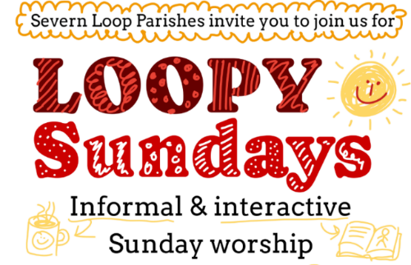
Our new, informal Sunday afternoon worship is continuing into March! We are meeting at 3pm on the 10th May at the Mission Church in Bomere Heath. Do join us for an afternoon of interactive Bible stories and activities, singing and snacking, suitable for all ages. This month will be all about things that go up, as our interactive story focuses on Jesus' ascension to heaven. Join us for informal worship, prayer activities, and the ever present refreshments. Feel free to just turn up, but if you’d like to find out more in advance, do email Dave - rev.latcham@gmail.com.

Wednesday eve Small Group
Join us on 6th and 20th May at 7:30pm in the Mission Church, Bomere Heath. For more details contact Dave - rev.latcham@gmail.com.
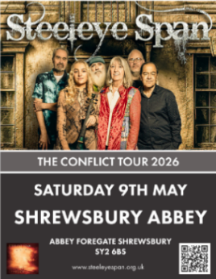

Steeleye Span Concert
Charles Bridgeman (Leaton) is promoting this concert on 9th May as a means of raising money for a family window- if you're interested in getting a ticket, please contact him directly- Cbridgeman@leatonforest.co.uk.

Of One Accord Concert- 5th June 2026

A wonderful evening of uplifting music with Of One Accord, a mixed voice choir nestled in Shrewsbury. Tickets: £10 Including refreshments
To book your tickets, please contact Wendy/Clare – 01743 850237/01743 361906 or e-mail severn.loopparishes@gmail.com



Boardgames and Puzzles afternoon at Bomere Heath Mission Church
Join us for a fun afternoon during the May half term holidays to play Boardgames and Puzzles on Sat 30th May, 2-4:30pm, at the Mission Church in Bomere. This free event will have a selection of boardgames and puzzles for all ages and abilities, as well as refreshments. Do drop in, and for more information contact Dave on rev.latcham@gmail.com

Dave’s Priesting Service
You’re warmly invited to join us on Sunday 21st June at 10:30am at Bicton Church, followed by a bring-and-share lunch. Do save the date- we would love to have loads of folk there to support him!


Coach Trip to Coventry Cathedral
It’s been a few years, but we are delighted that the
Severn Loop Coach Trip is back!
16th of July, including a tour around the ruins and new Cathedral,
cream tea then finishing with choral evensong!
Please save the date- more information coming soon!


Grief Encounters
We are beginning a new ministry- an informal friendship café for the recently bereaved. We are hoping to run one three times a year, at different locations. Hannah will be writing to the families of those whose funerals we looked after, to invite them along. We’re very much aware that also includes quite a few of you- if you are interested in finding out more, do contact Hannah. The first one will be at Shrawardine, 30th June, 4pm.


Royal British Legion Service at Bicton- 7th June, 6pm
As usual, we have our annual service at Bicton for the local branch of the Royal British Legion, featuring the Porthywaen Brass Band. Gather at 5.45pm (or just before) to see them march up from the club (they’ll also march back afterwards). All welcome.

Diary Dates
CAMEO Coffee Morning at Bicton Church- 14th May, 10.30am-11.30am.
The Stepping Out Café in Bomere Heath- 27th May, 2.30pm-4pm
Friends Coffee Morning in Shrawardine- 12th May, 10.30am, in church
Filling Station- 19th May, 7.15pm for 7.30pm, Knockin Assembly Rooms. Free refreshments.
REVS- 16th May, 10am-noon, Leaton Church
Loop Explorers (4.30pm-5.30pm, Bicton Church, for primary school children)- 7th May, 21st May
Loop Life (7pm-8pm at the Rectory in Bicton, for youth)- 14th May

For Your Prayers
- For our local farmers.
- For peace in Sudan, the Middle East and Ukraine.
- For our Government and armed forces, and for HM the King.
- For schools, including our new lunch club at Corbet School, exploring the questions of faith.
- For those in hospital, and for our NHS.
- For the recently bereaved- particularly the family and friends of Tim Empson and Arthur Roberts.
- For couples preparing for marriage.

Readings for May
DAY | PSALM | 1ST READING | 2nd READING/ GOSPEL
3rd May  Fifth Sunday of Easter | Psalm 31.  1-5, 15-16 | 1 Peter 2. 2-10 | John 14. 1-14
10th May  Sixth Sunday of Easter | Psalm 66.  7-18 | 1 Peter 3. 13-22 | John 14. 15-21
17th May  Seventh Sunday of Easter | Psalm 68.  1-10, 32-35 | 1 Peter 4. 12-14 &  5: 6-11 | John 17. 1-11
24th May  Pentecost | Psalm 104.  26-36, 37b | Acts 2. 1-21 | John 20. 19-23
31st May  Trinity Sunday | Psalm 8 | 2 Corinthians 13. 11-13 | Matthew 28. 16-20
4th June  Corpus Christi | Psalm 116.  10-17 | 1 Corinthians 11. 23-26 | John 6. 51-58

SUNDAY SERVICES FOR MAY

 | Albrighton | Bicton | Bomere  Heath | Fitz | Leaton | Montford | Shrawardine
3rd May  Easter 5 | 9.15am  HC | 11am  HC |  | 9.30am  MP | 10.45am  MP |  | 9.30am  MP
10th May  Easter 6 |  | 11 am  MP | 9am  HC  3pm Loopy Sunday |  | 10.45 am  MP | 9.30 am  MP | 11 am  HC
14th May  Ascension Day | 4pm  Battlefield
17th May  Easter 7 | 9.15am  MP | 11 am  MP |  | 9.30am  HC | 10.45 am  HC | 9.30am  MP
24th May  Pentecost |  | 11am  HC | 9am  HC |  | 10.45am  MP | 11am  HC | 9.30am  HC
31st May  Trinity Sunday | 10.30am  United Service
7th June | 9.15am  HC | 6pm  RBL |  | 9.30am  MP | 10.45am  HC |  | 9.30am  MP

HC- Holy Communion; MP- Morning Prayer
OTHER WAYS TO WORSHIP ON SUNDAYS- SUNDAY AT SIX 6 pm via Zoom – email Peter or Hannah to receive the link. DAILY HOPE – national phone line, see number above. LICHFIELD CATHEDRAL- www.lichfield-cathedral.org 10.30 am Eucharist

