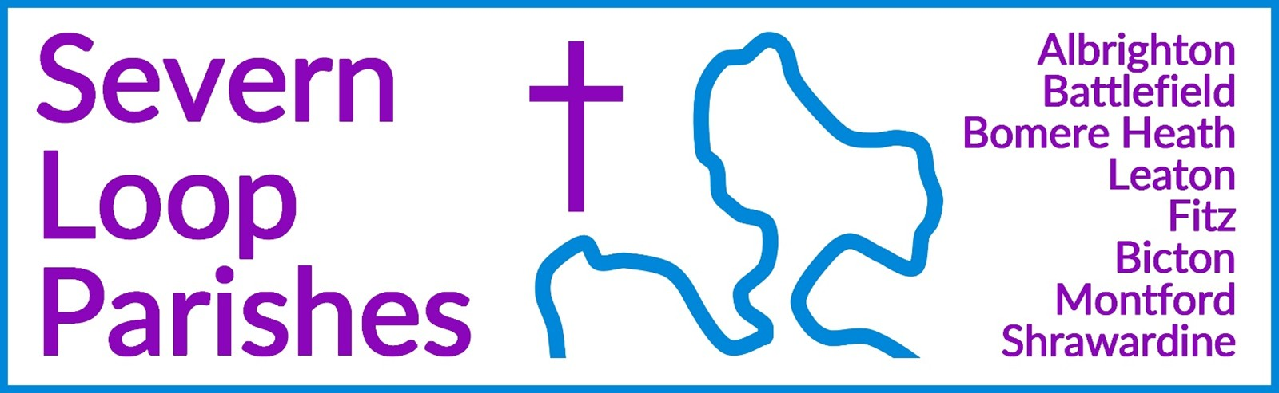
Priest in Charge: | Revd Hannah Lins | revhannahlins@gmail.com, 07736 012011
Assistant Priest:  Curate: | Revd Peter Allan  Revd David Latcham | pallan412@gmail.com, 01939 290048  rev.latcham@gmail.com, 07745 968298
Pastoral Minister: | Mrs Joyce Jagger | pearhill1@outlook.com, 07802 695954
Safeguarding Officer: | Mrs Philippa Herbert | 07871 865253
Administrator: | Miss Rosie Dixon | severn.loopparishes@gmail.com
Daily Hope (the national phoneline service) |  | 0800 8048044
Weekly Collects, readings and reflections are on the website- www.severnloopparishes.org.uk |  | 
JULY LOOP 2026

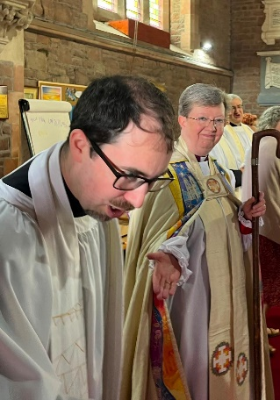
A big thank you from Dave:

Thank you so much to everyone who was present at, contributed to, and was thinking and praying for me around the priesting service on 21st June. It was particularly special to be ordained as priest within the parishes I'm serving here. Thank you so much for your generosity, of heart and warmth in receiving me this past year, and especially in the gifts you gave me. It's a real privilege to see the love and kindness of God reflected within you all.

Loopy Sundays

We are meeting at 3pm on the 12th July at the Mission Church in Bomere Heath. Join us for our cafe style monthly service, with an interactive retelling of a bible story, informal atmosphere, and refreshments.
Join us for informal worship, prayer activities, and the ever-present refreshments. Feel free to just turn up, but if you’d like to find out more in advance, do email Dave – rev.latcham@gmail.com.

Wednesday eve Small Group
Join us on first and third Wednesday of the month at 7:30pm in the Mission Church, Bomere Heath. If you have questions about the bible, and want to explore what it says, we'll be meeting 1st and 15th July to continue looking at the letter of John. All welcome to come and try it out. For more details contact Dave – rev.latcham@gmail.com.

Ladies Afternoon Tea
4th July at 2.30pm at the Mission Church Bomere Heath
Speaker: Revd. David Latcham
Tickets £5 from church on a Sunday or 290637 or 290604

Teddy Bear Parachute Drop
Saturday, 11th July 2026 11.30am-1pm at Bicton Church

Make a parachute for your teddy and bring it along, refreshments available! We had great fun a couple of years ago, and are looking forward to a fab morning (top tip: plastic shopping bags fashioned into a parachute work very well!).

Boardgames and Puzzles afternoon
Monday 20th July, 2-4:30pm, Bomere Mission Church
We're making time to play again at our free, drop in afternoon. There will be boardgames and puzzles for all ages and abilities, alongside refreshments.
Contact Rev. Dave if you want more details.

CANCELLED: Mary Magdalene Fair
25th July, Battlefield Churchyard
The Churches Conservation Trust visited and deemed the church tower unsafe because of a wobbly pinnacle. The church is now locked and cordoned off until it is removed- so without access to shelter and electricity (and the inspiration for all our craft ideas), the fete isn't really viable.

Diary Dates
CAMEO Coffee Morning at Bicton Church- 9th July, 10.30am-11.30am.
Shrawardine Coffee Morning- 21st July, 10.30am- noon
The Stepping Out Café in Bomere Heath- 29th July, 2.30pm-4pm
Filling Station- 21st July, 7.15pm for 7.30pm, Knockin Assembly Rooms. Free refreshments.
REVS- 18th July, 10am-noon, Leaton Church

For Your Prayers
- For all affected by the changing climate, particularly the recent heatwave.
- For our local farmers.
- For the people of Venezeula.
- For all preparing for marriage, baptism or confirmation.
- For our upcoming social events- see above.
- For those who are unwell.
- For our NHS.

Holidays and leave
We are very grateful to our worship teams and to Pat Hall, all of whom take on a heavier load as we go on our holidays in July and August! Peter is away for the first part of July (back by 19th). Dave is away from 23rd July- 3rd August inclusive. Hannah is away for three weeks in August, and 27th-29th July.

Readings for July
DAY | PSALM | 1ST READING | 2nd READING/ GOSPEL
5TH July  Trinity 5 | Psalm 145  8-15 | Romans 7  15-25a | Matthew 11  16-19, 25-30
12th July  Trinity 6 | Psalm 65  8-13 | Romans 8  1-11 | Matthew 13  1-9, 18-23
19th July  Trinity 7 | Psalm 86  11-17 | Romans 8  12-25 | Matthew 13  24-30, 36-43
26th July  Trinity 8 | Psalm 119  129-136 | Romans 8  26-39 | Matthew 13  31-33, 44-52
2nd August  Trinity 9 | Psalm 145  8-9, 15-22 | Romans 9  1-5 | Matthew 14  13-21

SUNDAY SERVICES FOR JULY
 | Albrighton | Bicton | Bomere  Heath | Fitz | Leaton | Montford | Shrawardine
5th July  Trinity 5 | 9.15am  HC | 11am  HC |  | 9.30am  MP | 10.45am  HC |  | 9.30am  MP
12th July  Trinity 6 |  | 11 am  MP | 9am  HC |  | 10.45 am  MP | 9.30 am  HC | 11 am  HC
19th July  Trinity 7 | 9.15am  MP | 11am  HC |  | 9.30am  HC | 10.45am  HC | 9.30am  MP
26th July  Trinity 8 |  | 11 am  MP | 9 am  HC |  | 10.45 am  MP | 11 am  HC | 9.30 am  HC
2nd August  Trinity 9 | 9.15am  HC | 11am  HC |  | 9.30am  MP | 10.45am  HC |  | 9.30am  MP

HC- Holy Communion; MP- Morning Prayer

OTHER WAYS TO WORSHIP ON SUNDAYS- SUNDAY AT SIX 6 pm via Zoom – email Peter or Hannah to receive the link. SHARING THE LIGHT IN THE LOOP- weekly phone line worship – see top of this page for the number. DAILY HOPE – national phone line, see number above. LICHFIELD CATHEDRAL- www.lichfield-cathedral.org 10.30 am Eucharist

